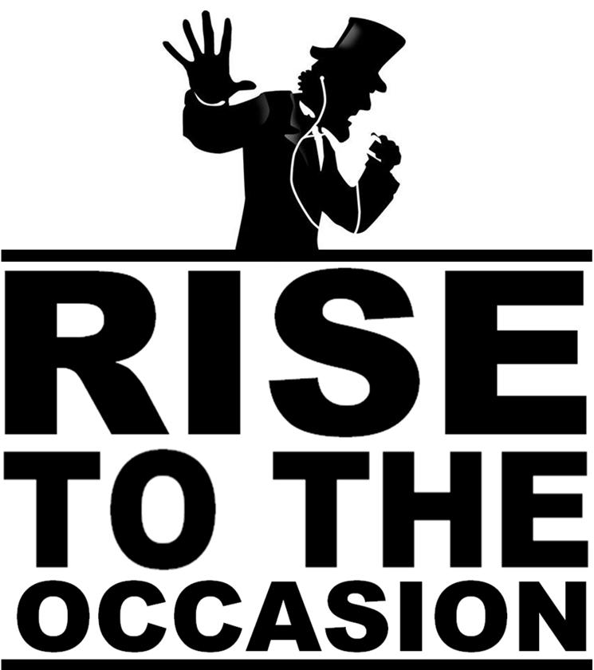
Advanced Placement United States History – Thematic Review

Table of Contents

People on the Move
Pilgrims to Political Refugees
[Pages 4-12]

African American History
Slavery, Abolition, Accommodation, Agitation, Recognition, Confrontation
[Pages 13-21]

Native American History
Confrontation, Forced Assimilation, reservations
[Page 23]

Women’s History
From the Cult of Domesticity to the Feminine Mystique
[Pages 24-28]
Reform Movements
Movements of Social Protest in American History
[Pages 29-36]
American Government
Role and Function of Government, Political Parties and Branches in Action
[Pages 37-61]

Economic and Labor History
Government and the Economy/the Labor Movement
[Pages 62-74]

People on the Move
Pilgrims to Political Refugees
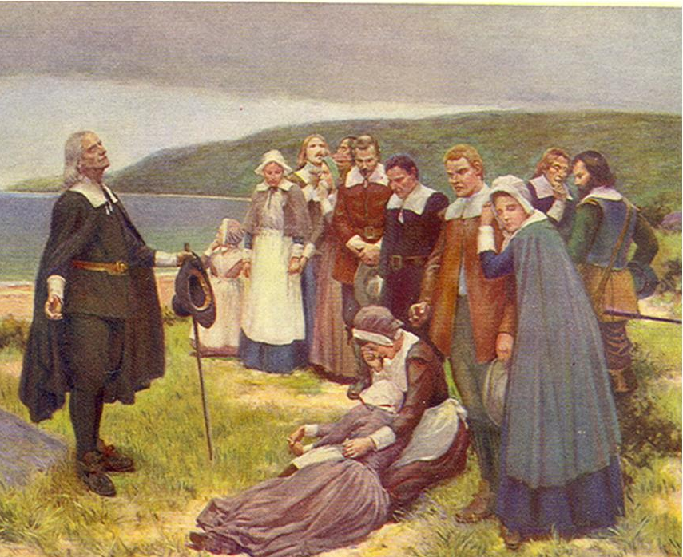  The Pilgrims | 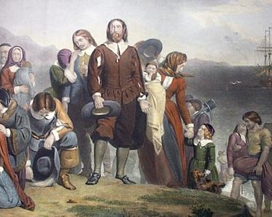  The Puritans | 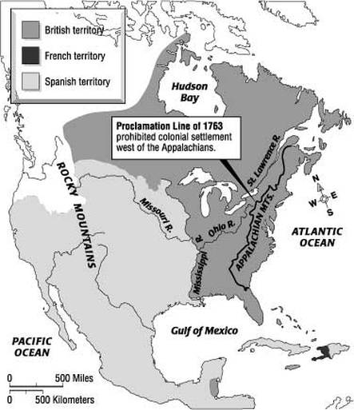  Proclamation of 1763
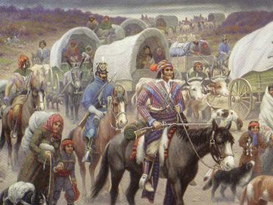  Trail of Tears | 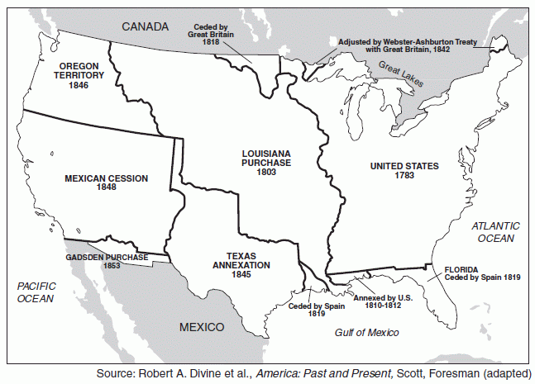  Manifest Destiny | 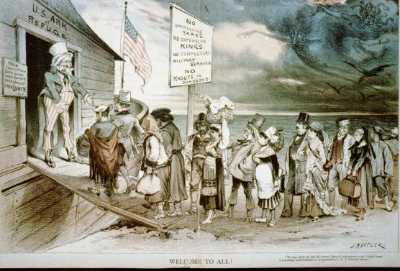  Old Immigration
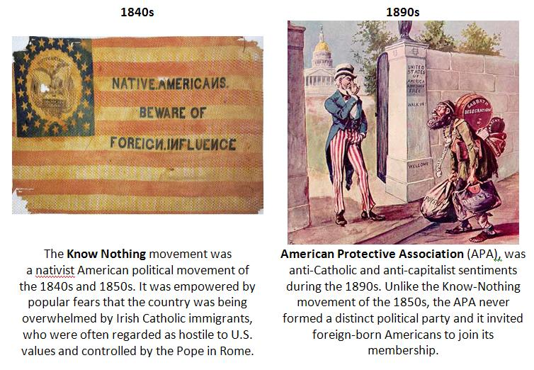  New Immigration | 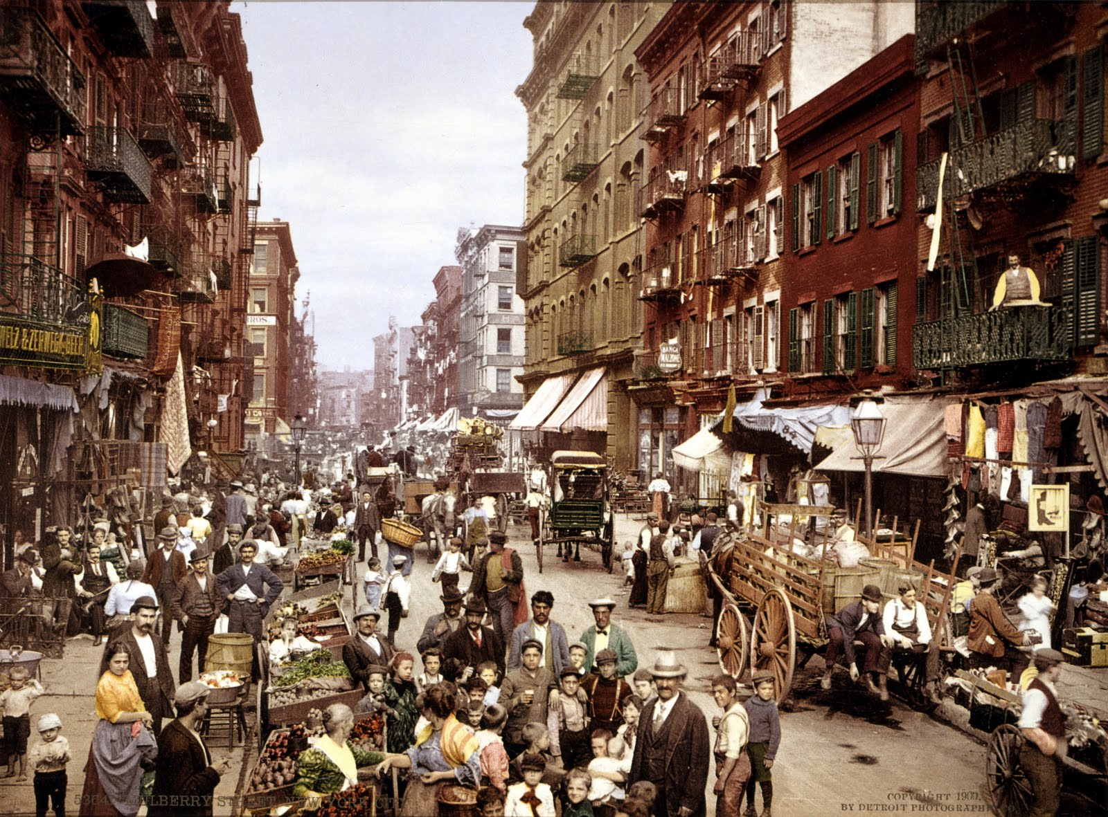Rise of the American City | 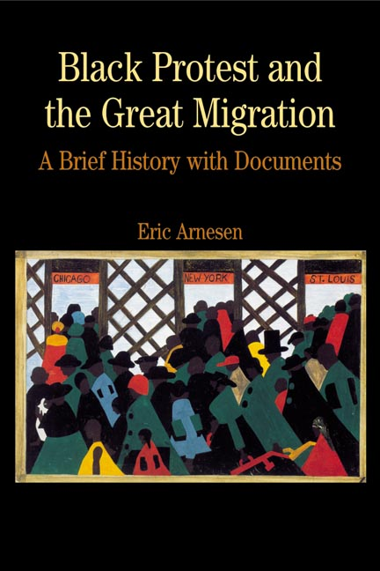  The Great Migration
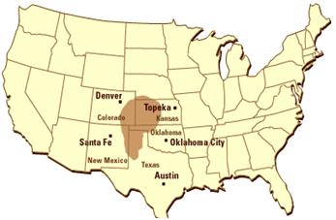  The Dust Bowl | 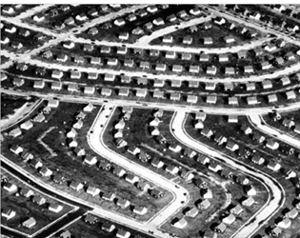  Suburbanization | 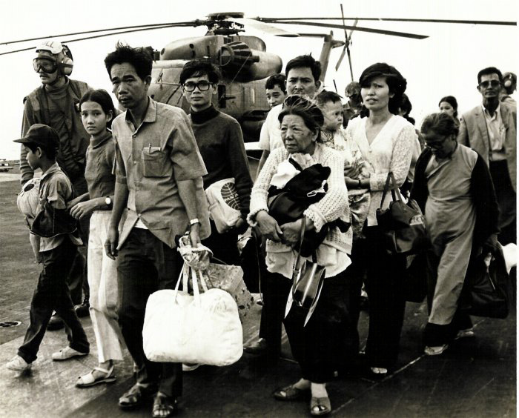  Refugees

People on the Move
1450 to 1650
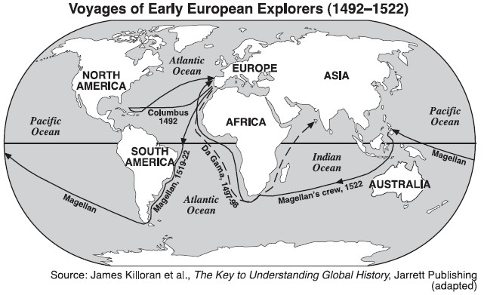

GLOBAL NETWORK
An exchange of goods, services, and cultures developed among the continents of
Europe, Asia, Africa, and the Americas

International Trade

Redistribution of wealth

Diffusion of European values and religion

Triangular slave trade 1500-1800 - “African Diaspora”

Redistribution of world’s population (voluntary and involuntary)

Redistribution of plants and animals - “Columbian Exchange”

Disease Indians are unprepared and unexposed to European disease

People on the Move
The Age of Exploration - Notable dates and personalities
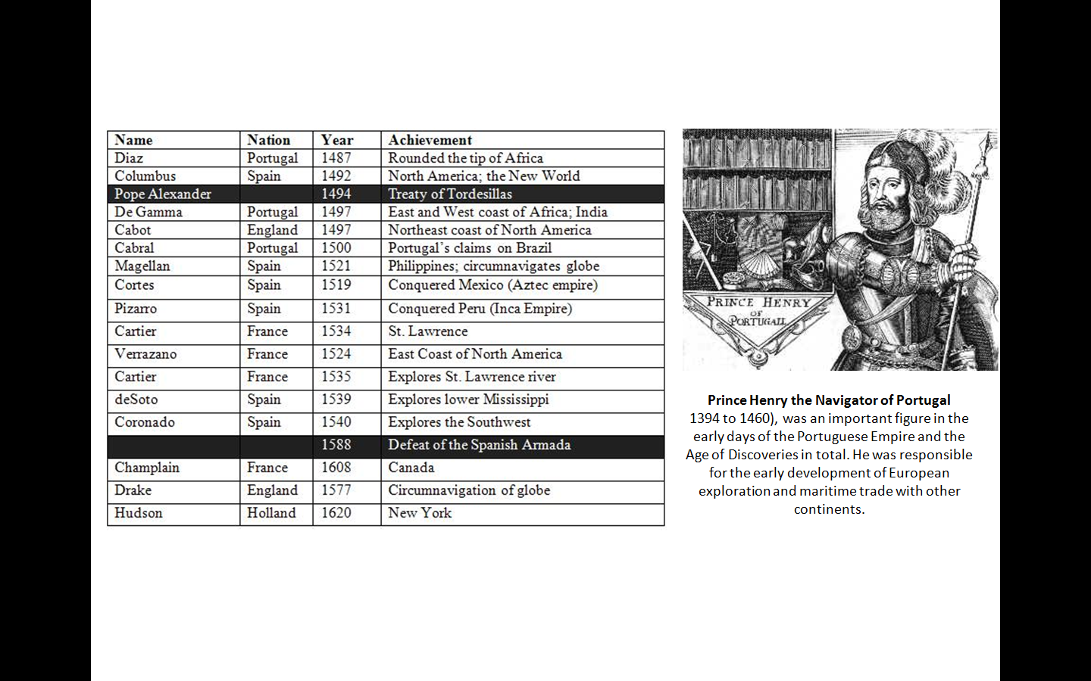
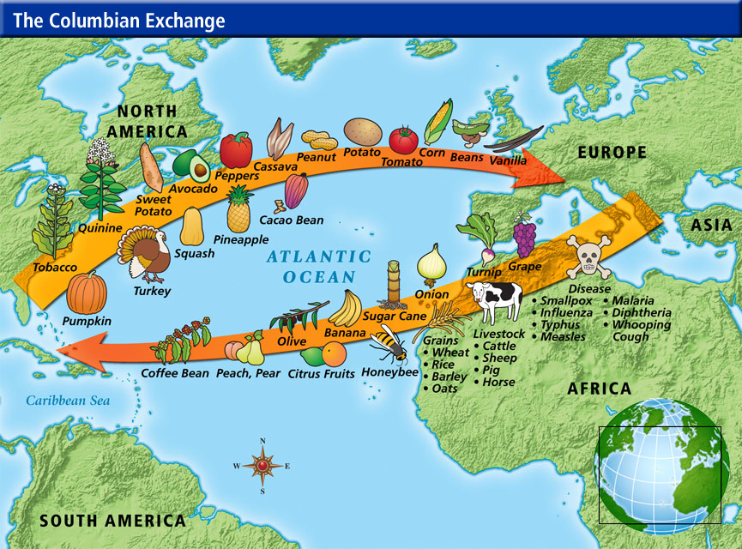

People on the Move
Slavery in the Colonies/the Economics of Slavery
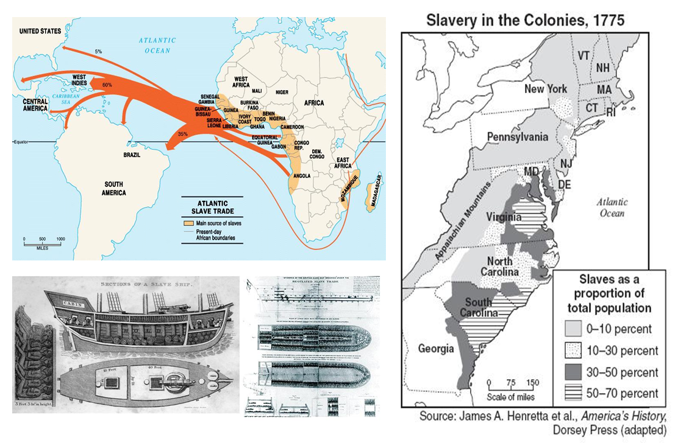
All told 11 million Africans were torn from their homes “African Diaspora”

Most of them were shipped to the West Indies and South America, but a sizable portion went to the North American colonies

An attractive option for labor starved colonists
“Social death” at birth eliminated a slaves political life/Permanent – it could be passed on generationally
ALL the colonies participated is slavery, but the concentrations varied; The greatest concentration of slave labor was in the Carolinas; Slave labor participated in almost every aspect of the colonial economy ; Slavery generated conflict and treason, resulting in slave revolts

People on the Move
Timeline English settlement of the New World
1607 | Settlement of Jamestown - the Virginia Company (Joint Stock Company ) pursues the settlement of Jamestown in a marshy and fever ridden section of the new world. No clear focus on the purpose of the colony. Of the 104 settlers over ½ are considered Gentlemen Notables: John Smith, John Rolfe and tobacco crop economy (Introduced in 1612)
1619 | House of Burgesses formed, Slave trade begins
1620 | Pilgrims (radical separatists) set sail on the Mayflower to Plymouth Bay. While the southern colonies were being established mostly for the sake of profit, a group of northern colonies was founded mostly for the sake of ideas. The New England Settlement was purposely founded for English radical Protestant refugees. The group settled outside the domain of the Virginia Company and, without legal permission, settled in Plymouth Bay in 1620. Before disembarking from the Mayflower, the Pilgrim leaders drew up and signed the Mayflower Compact (1620)
1624 | Dutch found New Netherland
1629 | Charles I dismisses Parliament and persecutes Puritans; In 1629, an energetic group of non-Separatist Puritans, fearing for their faith and for England's future, secured a royal charter to form the Massachusetts Bay Company. (Massachusetts Bay Colony)  John Winthrop - Governor of Massachusetts Bay Colony Covenant Theology: Winthrop believed Puritans had a covenant with God to lead new religious experiment in New World "We shall build a city upon a hill"
1630 | Puritans found Massachusetts Bay Colony The "Great Migration" (1630’s) During the Great Migration of the 1630s, about 70,000 refugees left England for America. Most of them were attracted to the warm and fertile West Indies, especially the sugar-rich island of Barbados. By 1631, 2,000 colonists had arrived in Boston and had settled a number of towns around it as well. This was a simple agreement to form a crude government and to submit to the will of the majority under the regulations agreed upon. It was signed by 41 adult males. It was the first attempt at a government in America.
1635- 36 | Notable Dissenters in the Bible Commonwealth: Roger Williams- popular Salem minister who also challenged the Church; an extreme Separatist; was banished from the Massachusetts Bay Colony.
1635- 38 | Connecticut and New Haven colonies founded
1637 | Pequot War (1636-1637) was a reaction to white encroachment. Despite Puritan victory over Indians, New England colonies realized collective security was necessary for future defense. Connecticut towns sent 90 men who opted to attack a smaller village of non-combatants where 400 Indian men, women and children were slain
1638 | Anne Hutchinson banished from Massachusetts colony Anne Hutchinson- an intelligent woman who challenged the Puritan orthodoxy; was banished from the Massachusetts Bay Colony because of her challenges to the Church.
1639 | Connecticut's Fundamental Orders drafted (First modern constitution in American history)  1. Established a democracy controlled by "substantial" citizens  2. Gov’t should be based on consent of the people.  3. Patterned Massachusetts’ gov’t.  4. Foundation for Connecticut’s colonial charter and later, its state constitution.

People on the Move
Continental Migration 1650 to 1850
The territory the U.S. purchased or won in war between 1783 and 1853 was occupied by Native Americans who also claimed the land. During the 1840’s, Americans expanded westward. Manifest destiny, the belief that occupying land from the Atlantic to the Pacific Ocean was America’s God-given right, became a national passion. Manifest Destiny, the belief that the United States is divinely inspired to spread across the nothing short of unbridled imperialism

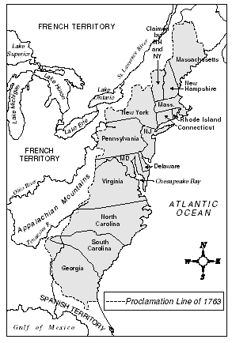 | PROCLAMATION of 1763 - The ruthlessness of the conflict was a reflection of a growing racial divide between British colonists and American Indians. The British government sought to prevent further racial violence by issuing the Proclamation of 1763, which created a boundary between colonists and Indians.  13 ORIGINAL STATES 1783 The U.S. won the Revolutionary War and was granted independence by Great Britain in 1783 Review ….Articles of Confederation  TREATY OF 1783 The Treaty of Paris, which officially ended the Revolutionary War, resulted in Great Britain ceding the Northwest Territory to the U.S. In return, the U.S. agreed to pay debts owed to British investors and not to prosecute colonists who remained loyal to Britain during the war.

LOUISIANA PURCHASE (1803) In 1800, the U.S. feared the closing of the Mississippi River to United States by France. President Jefferson tried to buy the port of New Orleans and West Florida from France and obtain a guarantee that U.S. vessels cold navigate the Mississippi River. France offered to sell the entire Louisiana Territory. After considerable deliberation, the strict constructionist Jefferson, purchased the Louisiana Territory for $15 million.

FLORIDA (1819) In 1818, General Andrew entered Florida (a colony of Spain) to attack the Seminole Native Americans who were raiding settlers in Georgia. The U. S. demanded that Spain control the Native Americans or sell Florida to the U. S. In 1819, Spain sold Florida to the U. S. for $5 million.

TEXAS (1845) In 1821, Mexico (a colony of Spain) became independent. Americans, especially cotton growers, began moving to Texas, a territory within Mexico’s border. Fearing that U. S. Settlers were becoming too numerous and powerful , Mexico passed several laws which banned additional slaves in Texas. In 1836, Texas fought and won its independence from Mexico. Texas requested annexation into the U. S. but was opposed by northerners who feared the admittance of an additional slave state. Despite northern pressure, President Polk annexed Texas in 1845

MEXICAN WAR/MEXICAN CESSION (1846-1848) A boundary dispute with Mexico resulted from the U. S. annexation of Texas in 1845. Mexico claimed that the boundary of Texas was the Nueces River while the U. S. claimed it was further south along the Rio Grande River. When Mexico refused to sell California to the U. S., President Polk sent troops into the region and fired upon the U. S. troops they felt entered Mexican territory. By 1847, Mexico had surrendered to superior U. S. forces. As a result of the 1848 peace treaty, Mexico ceded much of present-day southwest and California to the United States (Mexican Cession) and settled on the Rio Grande as the boundary of Texas. The U. S. agreed to pay Mexico $15 million.
OREGON TERRITORY (1848) Since Britain and the U. S. settled the Oregon Territory jointly, there was no specific boundary. U. S. expansionists wanted all of the Oregon Territory. Presidential Polk, whose campaign platform called for total control of the disputed territory, eventually compromised with Great Britain and the boundaries of the Oregon Territory were established at the 49th parallel.

GADSDEN PURCHASE (1853) Acquire from Mexico for $10 million, the land was to be used for the transcontinental railroad. Many historians feel the large sum of money for such a small parcel of land was compensation for land taken from the Mexican War.

People on the Move
Waves of Migration 1800 - 1965

Movement and Migration | Reaction
OLD IMMIGRATION 1800-1850  (Second Wave of Immigration) Although the Jacksonian time period is known as the “age of the common man” it did not embrace the immigrants.  During the 1840’s and 1850’s large numbers of Irish and Germans began arriving. The Irish settled into Eastern cities. The Germans moved to the Midwest. | Nativism - distinguishes between Americans who were born in the United States, and individuals who have immigrated - 'first generation' immigrants. They even formed the political party called the Order of the Star Spangled Banner, more commonly known as the Know-Nothings.  WHY? Threats involving language, jobs, pay-scales, control of the government, control of borders (and fears of invasion), moral values, and loyalties to racial and ethnic groups, are involved in nativism, with the exact ingredients varying widely.
EXODUSTERS (1879 and 1880) At the conclusion of the Civil War, many blacks moved to Kansas and were known as exodusters. This is known as the first great African American migration. Those who stayed in the south ended up as tenant farmers or sharecroppers. It was nearly identical to slavery, with the former masters in charge once again.
RURAL TO URBAN MIGRATION (1870s–1920s)  In the late nineteenth century, American was increasingly dominated by large urban centers. Explosive urban was accompanied by often disturbing changes | 1920 Census – 51% of Americans lived in urban centers of 2,500 people or more
NEW IMMIGRATION 1880-1924 (Third wave of immigration) There is a shift in where Immigrants come from. These new immigrants arrived from southern and eastern Europe. 1890 Eastern Europe different religion – Catholic and Jewish = tension with Protestants | They were looked down upon by the more established English, German, and Irish immigrants. The new immigrants were usually poor and possessed limited skills.  They typically went to work in factories where they were treated poorly, working long hours for very low pay. This situation led to them putting their entire family to work just to survive.  Unfortunately, the children didn‘t get an education which would doom them to a life of working in factories themselves without a chance for improvement.  The Chinese Exclusion Act, 1882 was passed that outlawed Chinese immigration for ten years
Movement and Migration |  | Reaction
NEW IMMIGRATION 1880-1924 (Third wave of immigration) There is a shift in where Immigrants come from. These new immigrants arrived from southern and eastern Europe. 1890 Eastern Europe different religion – Catholic and Jewish = tension with Protestants |  | Literacy Test Act (1917) Passed over Wilson’s Veto  Immigrants had to be able to read and write a language to get in Didn’t have to be English  1921 Emergency Quota Act, and May 26, 1921, Johnson–Reed Immigration Act—for the first time the United States limited the admission of (mostly) European persons based on their nationality and the proportion of people of such nationality among all foreign-born persons in the United States (quotas). In 1924 the maximum was 3 percent of those born outside of the United States present in 1910.  The trial of immigrant anarchists Sacco and Vanzetti highlighted to the world just how nativist and anti immigrant that America had become.
THE GREAT MIGRATION (1910 to 1930)  The "Great Migration" increased dramatically in the years between about 1910 and the early 1920s. Between 300,000 and 1,000,000 African-Americans moved north during this period, largely in response to an increased number of unskilled factory job openings as northern manufacturers boosted production for World War I. |  | Black migration between 1916 and the 1960s remained strong, except during the Great Depression. More than 6 million southern blacks made the move to the North during this period.  REACTION: Revival of the new and improved Ku Klux Klan
MEXICAN MIGRATION (1877 to 1910) Mexican immigration in the 20th century came in three great surges of growth. The first surge began in the 1900s. Revolution in Mexico and a strong U.S. economy brought a tremendous increase in Mexican immigration rates. Between 1910 and 1930, the number of Mexican immigrants counted by the U.S. census tripled from 200,000 to 600,000. |  | For many Mexican immigrants, moving to the U.S. was not necessarily a one-time journey of permanent relocation. Since the distance was so short, Mexican citizens could return home relatively easily, and many did so--because of improved conditions in Mexico, because of family concerns, or because they had earned enough money to live more comfortably. In the 1910s and 1920s, it is estimated that more than 1 million Mexican immigrants returned to Mexico.

People on the Move
Summary of Immigration Laws

Selective | Restrictive
Note that in 1875, 1882 and 1892 Congressional acts provided for the examination of immigrants and for the exclusion from the U.S. of convicts, polygamists, prostitutes, persons suffering from loathsome or contagious diseases, and persons liable to become public charges.  Chinese Exclusion Act (1882/1904)  Barred Chinese laborers from entering the country for 10 years; made permanent in 1904. U.S. citizens complained that those who had entered from the 1850s forced wages down. “Yellow Peril” was also evident (Fear of the economic success of this culture and the success of the later generations). Note that this was preceded by a Congressional law in 1862 forbidding American vessels to transport Chinese immigrants to the U.S. (Repealed in 1943.)  Gentlemen’s Agreement (1907)  Ban on Chinese workers extended to Japanese. Excluded from these two acts were Asian females who were allowed into the U.S. so that they could marry the Asian men so as not to “pollute” the races. (Do you believe that!!!)  Literacy Act (1917)  Required all immigrants be able to read and write English or some other language. Created an Asiatic Barred Zone to shut out Asians. Aliens unable to meet minimum mental, moral, physical and economic standards were excluded, as were anarchists and other so-called subversives. This part was further strengthened in 1918 by the Anarchist Act of 1918. Vetoed by Woodrow Wilson Congress was successful in overriding the veto. | Emergency Quota Act (1921)  This act would allow the number of aliens of any nationality admitted to the U.S. in a year could not exceed 3% of the number of foreign-born residents of that nationality living in the U.S. in 1910.  National Origins Act (1924-29)  150,000 immigrants allowed per year; new quota would be based on the number of persons of that nations stock as of 1920. The minimum quota for each country was 100 persons (although Asians are completely excluded). No quotas or limitations were applied to the Western Hemisphere.  Refugee and Displaced Persons Act (1948)  Allowed WWII aliens into the U.S.; this act has resurfaced with the use of Congressional decrees when appropriate.  McCarren-Walter Act (1952)  This act continued the National Origins Act raising the number of immigrants to 156,000 per year with no quota for the Western Hemisphere. A token quota of 2,000 was assigned to Asia. Present or former members of communist parties or dictatorships are barred. A provision is made to deport subversives.  Immigration Act of 1965  This law is a reaction to the “racism” of the above policy. It repeals the quota system. A ceiling of 170,000 persons is set on admission from outside the Western Hemisphere with a maximum of 20,000 from any one country. Preference is given to those with skills needed by this country. Exemptions to this rule apply to immediate relatives of U.S. citizens who are welcomed regardless of skills. A ceiling of 120,000 immigrants from within the Western Hemisphere is added. Note that laws passed in 1968 and 1977 eventually raised the quota to 290,000 immigrants worldwide with a maximum of 20,000 for any one country, thus abolishing limits for hemispheres. A 1980 act reduced the quota to 270,000.

African American History
Slavery, Abolition, Accommodation, Agitation, Recognition, Confrontation

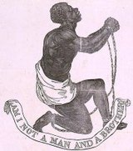  Slavery and Three Fifths Compromise | 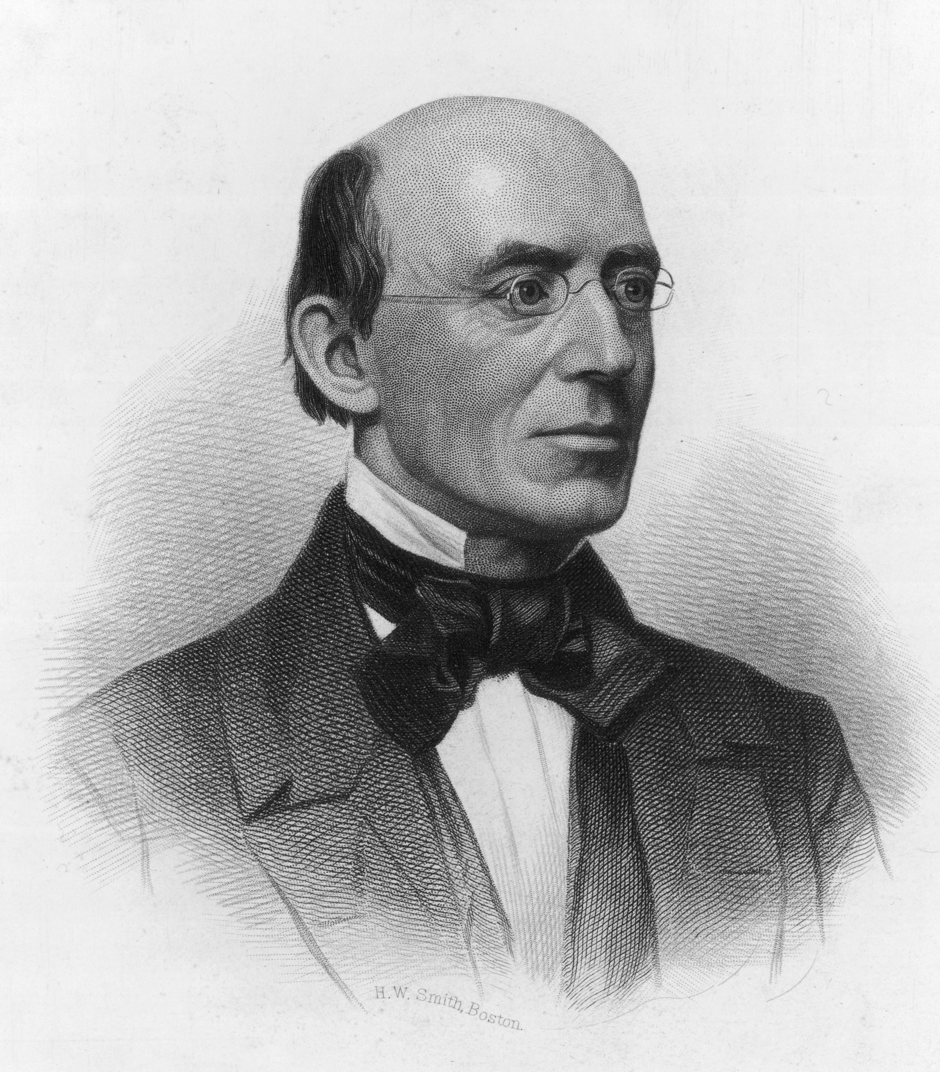  William Lloyd Garrison | 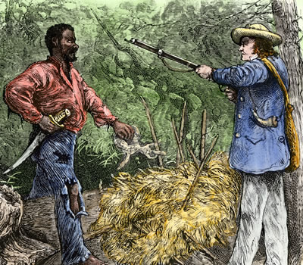  Nat Turner
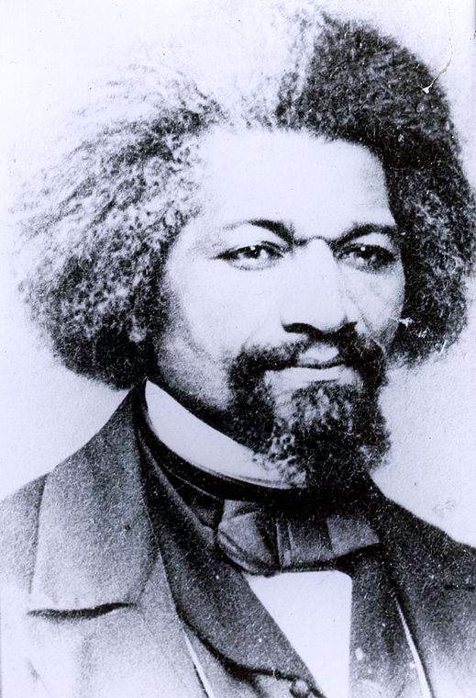  Frederick Douglass | 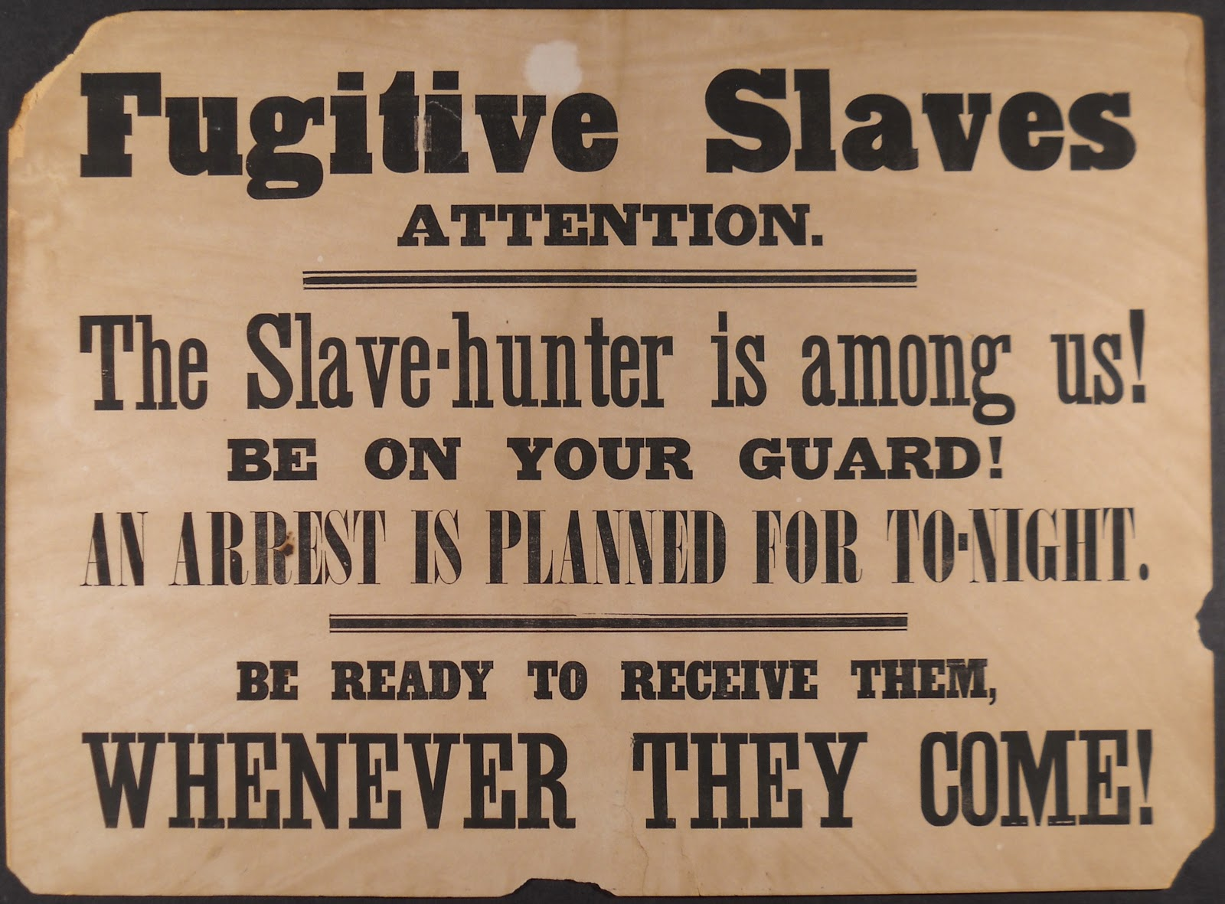  The Fugitive Slave Act | 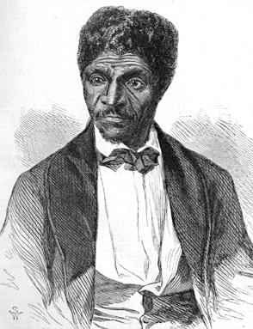  Dred Scott vs Sanford
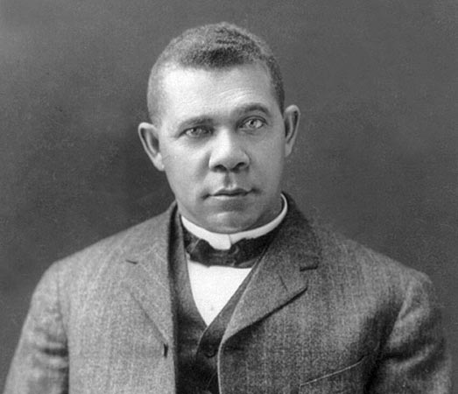  Booker T Washington | 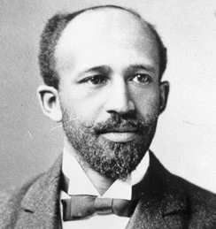  WEB DuBois | 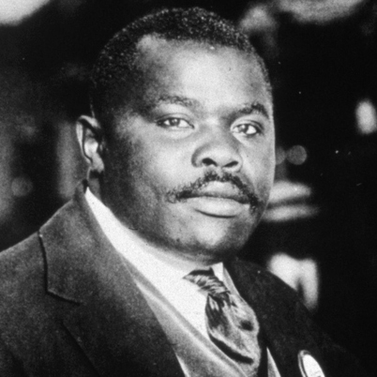  Marcus Garvey
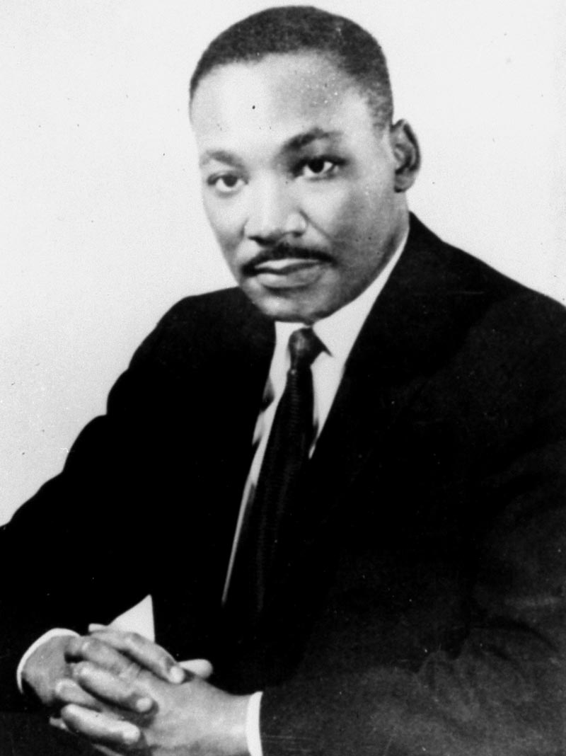  Dr. Martin Luther King Jr. | 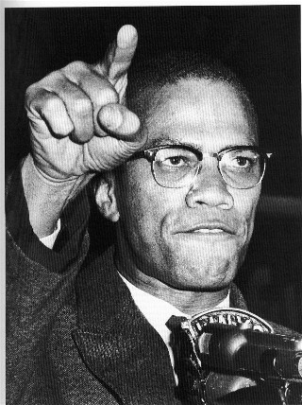  Malcolm X | 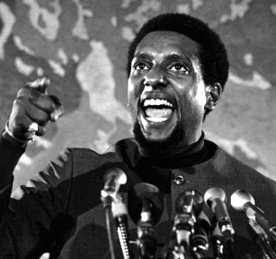  Stokely Carmichael

African American History
Servitude and slavery to Emancipation 1619 to 1863

Chesapeake Region, 1619-1690 | Indentured servants Because of the massive amounts of tobacco crops planted by families, "indentured servants" were brought in from England to work on the farms. In exchange for working, they received transatlantic passage and eventual "freedom dues", including a few barrels of corn, a suit of clothes, and possibly a small piece of land
Growth of Plantation Economies | The Slave Trade - Africans had been brought to Jamestown as early as 1619, but as late as 1670, they numbered only about 2,000 in Virginia-only about 7% of the total population of the South.  In the 1680s, the wages in England rose, therefore decreasing the number of indentured servants coming to America. By the mid-1680s, black slaves outnumbered white servants among the plantation colonies' new arrivals.
Stono Rebellion, 1739 | The Spanish empire enticed slaves of English colonies to escape to Spanish territory. In 1733 Spain issued an edict to free all runaway slaves from British territory who made their way into Spanish possessions. On September 9, 1739, about 20 slaves, mostly from Angola, gathered under the leadership of a slave called Jemmy near the Stono River, 20 miles from Charleston. 44 blacks and 21 whites lost their lives. South Carolina responded by placing import duties on slaves from abroad, strengthening patrol duties and militia training, and recommending more benign treatment of slaves.
Prosser’s Rebellion, 1800 | When the day of the revolt arrived though, a violent storm washed out the roads and bridges leading to Richmond. The rebels broke up and Prosser was betrayed by one of his followers. The state militia captured Prosser and he and many of his followers were hanged.
Denmark Vesey's Conspiracy, 1822 | This failed insurrection was organized soon after the contentious debate over the admission of Missouri as a slave state. Like Gabriel, Vesey consciously looked to Haiti for inspiration and support.
Nat Turner, 1831 | This insurrection took place at a time when slaves in Jamaica had staged one of the largest revolts in history, when radical abolition had arisen in the North, and Britain was debating slave emancipation.

African Americans and Slavery 1776 to 1863
1776-The Declaration of Independence: It introduced equality as a basic democratic principle when it stated that all men were created equal. But it never addressed the slavery issue.  1789-Constitution is Ratified: According to the Constitution the slave trade could continue until 1808 and five slaves would be counted as three whites when determining representation in Congress. (3/5ths rule) This gave more power to southern whites in Congress.  1793-Invention of the Cotton Gin: As cotton production became easier and more profitable, Southern plantations prospered and became more dependent on slave labor. (Both tobacco and cotton production were labor intensive endeavors.)  1808-Congress Prohibits Slave Trade: This law made the foreign slave trade (importation of slaves) illegal although lack of enforcement by the federal government enabled the trade to continue.  1817-African Colonization Society Formed: Organized by white Virginians to establish a colony of freed slaves in Africa. The Society succeeded in founding the colony of Liberia on the west coast of Africa which became a Black republic in 1846.  1820-Missouri Compromise: This compromise settled the issue of slavery in the Louisiana Territory. Missouri was admitted as a slave state, Maine as a free state and all territory north of 36°30’ would be free territory.  1822-Slave Revolt Led By Denmark Vesey: Vesey, a former slave, organized a large group of African Americans from the Charleston, S.C. area and planned a slave revolt. The revolt failed and Vesey and 36 others involved in the revolt were hanged.  1830’s-Abolitionist Groups and the Underground Railroad Begin: Abolitionist groups called for the end of slavery. The Underground Railroad helped slaves escape to free territory. Abolitionists increased in numbers up to the Civil War while the Underground Railroad worked effectively throughout the ante-bellum period.  1831-Nat Turner Leads Slave Revolt: An African American slave led a rebellion of almost 70 slaves who killed more than 50 whites in Virginia. Turner and other leaders of the revolt were executed.  1831-The Liberator Begins Publication: William Lloyd Garrison began The Liberator, a weekly newspaper in Boston which called for an immediate end to slavery without any compensation to slave-owners.  1838-Frederick Douglass Edits the Northern Star: Frederick Douglass, a former slave, began editing the North Star, an anti-slavery newspaper, in Rochester, New York | 1840-Liberty Party Formed: The Liberty Party was the first political party promoting an anti-slavery platform.  1850-Compromise of 1850: This compromise allowed California to enter as a free state and ended the slave trade in Washington, D.C. Popular sovereignty would be used to determine the issue of slavery in the New Mexico and Utah territories.  1850-Fugitive Slave Law: State and local officials were responsible for capturing and returning runaway slaves to the South. Northern states passed Personal Liberty Laws which, in effect, nullified the Fugitive Slave Law.  1852-Uncle Tom’s Cabin: Written by Harriet Beecher Stowe, this best-seller depicted the cruelties of slavery. It called attention to the abolitionist movement in the North.  1854-Kansas-Nebraska Act: This act reopened the issue of slavery in Louisiana Territories and caused fighting between slavery and anti-slavery opponents in what became known as “Bleeding Kansas.”  1854-Republican Party Formed: Formed after the passage of the Kansas-Nebraska Act, the Republican Party took a stand against the spread of slavery into the territories.  1857-Dred Scott v. Sanford: The Supreme Court declared slaves to be property and stated that Congress did not have the Constitutional authority to legislate on the issue of slavery. The Missouri Compromise was ruled unconstitutional as a result.  1858-Lincoln-Douglas Debates: The much-publicized debates between the two Senate candidates from Illinois brought the issue of slavery to national attention.  1859-John Brown’s Raid: Brown, a white abolitionist, tried to encourage a slave revolt. His group seized U.S. weapons at Harper’s Ferry, Virginia. Federal troops captured and hanged Brown and his followers.  1860-Election of Abraham Lincoln: When Abraham Lincoln, a Republican, was elected President, the South feared slavery would be prohibited in new territories. They seceded from the Union and established the Confederate States of America.  1863-Emancipation Proclamation: President Lincoln’s proclamation freed all slaves living in the Confederate States of America.

African American History
Abolition, Reconstruction and the New South 1865 to 1896
WEB DuBois – Reconstruction was a “splendid failure” because it did not achieve its goals in any lasting manner – DuBois wrote one of the first major history of Reconstruction.

Legislation | Date | Purpose
13th Amendment | Submitted and ratified in 1865 | Abolishes Slavery in the United States
Freedman’s Bureau | 1865 and 1866 | Provides services for war refuges and freed people including food, medical aid, and education
14th Amendment | Submitted 1866 ratified in 1868 | Defines citizenship to include African Americans; guarantees due process and equal protection of the law and equal protection under the law
15th Amendment | Submitted 1869 ratified in 1870 | Guarantees that voting rights will not be denied on the basis of race
The Compromise of 1877 Rutherford B. Hayes won election, Republicans agreed to end reconstruction to pacify Democrats. Hayes promised to show concern for Southern interests and end Reconstruction in exchange for the Democrats accepting the fraudulent election results. He took Union troops out of the South.

Sharecroppers : South sought to revert the South to the antebellum (before the civil war) period and make blacks second class citizens in a role nearly identical to slavery. They forced the freedmen into an economic subservient situation similar to slavery known as sharecropping and tenant farming.

The Black Codes | Jim Crow Laws
Codes was a series of laws designed to regulate the affairs of the emancipated slaves. Mississippi passed the first such law in November 1865. The Black Codes aimed to ensure a stable and subservient labor force Blacks were forced to continue to work the plantations after their emancipation due to the system of "sharecropping." | were state and local laws in the United States enacted between 1876 and 1965. They mandated de jure racial segregation in all public facilities, with a supposedly "separate but equal" status for black Americans.

Plessy vs. Ferguson 1896
Homer Adolph Plessy, a light-skinned Louisiana black man, was arrested for sitting in a railroad car reserved by Louisiana law for whites. In a New Orleans court his lawyers argued that the law was unconstitutional, but Judge John H. Ferguson ruled against them, on the ground that the railroad had provided separate but equally good cars for blacks, as the law required. This line of reasoning was upheld by the Supreme Court. The case is remembered today mainly for the dissent of Justice John Marshall Harlan. “Our Constitution is color-blind,” Harlan wrote. “The arbitrary separation of citizens, on the basis of race … is a badge of servitude wholly inconsistent with civil freedom.”
African American History
The Progressive Era, 1897 to 1917

No significant steps were taken during the Progressive Era to challenge the South's Jim Crow system, solidly in place by 1900, which kept Blacks in a 2d class citizen status until the 1960s. No books like Helen Hunt's Century of Dishonor challenged the American conscience toward the plight of Southern Black citizen

Booker T Washington: Washington (1856-1915)  (Accomodationism or gradualism) | W.E.B DuBois (1868-1963)  (Interracialism or confrontationalism)
Helped establish Tuskegee Institute in Alabama in 1881 as a vocational and teacher’s college for African American. Economic gains would lead to cultural and intellectual accomplishments. He outlined this position, known as the “Atlanta Compromise,” in a speech at the Exposition of Cotton States in Atlanta in 1895 | A sociologist and historian who 1909 helped organize the National Association for the Advancement of Colored People (NAACP). He rejected Washington’s strategy because he felt Mr. Washington’s program practically accepts the alleged inferiority of African Americans.  Promoted the talented 10th

The NAACP 1909 | a biracial organization was founded in New York Its primary purpose became to challenge racial discrimination and segregation in public places through the legal system. Challenged laws which permitted the use of the mails to send publications fostering racial prejudice
Birth of a Nation (1915) | the highest-grossing film of its day, and is noted for its innovative camera techniques and narrative achievements. It has provoked great controversy for promoting white supremacy and positively portraying the "knights" (male members) of the Ku Klux Klan as heroes
Ida B. Wells A Red Record (1895) | Provided statistics on the lynching of African-Americans. IMPACT: NAACP joined the fight for Federal anti-lynching legislation

.
African American History
The 1920’s and the Great Depression
.

Harlem Renaissance was flowering of African American intellectual life during the 1920s and 1930s. It was also known as the "New Negro Movement
JAZZ ARTISTS OF THE TWENTIES | NOTABLE AFRICNA AMERICAN WRITERS
Duke Ellington, Bessie Smith, and Louis Armstrong. | Langston Hughes, Zora Neale Hurston, and Clause McKay

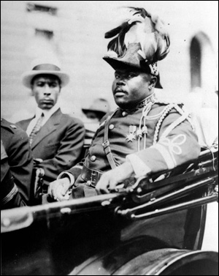  Marcus Garvey | Marcus Garvey Founder of the Universal Negro Improvement Association (UNIA) they emphasized separatism; established the Black Star Line a charter back to Africa for those who wanted to leave.  His importance declined, however, when his misuse of funds intended to establish a steamship company that would serve members of the African diaspora, the Black Star Line, resulted in a mail fraud conviction. He entered jail in 1925 and was deported to Jamaica two years later

Great Depression and the New Deal, 1929-1941
New Deal programs offer more opportunities to white men than to women and minorities. Women and African Americans are paid less for the same work.
New Deal programs did not directly confront racial segregation and injustice!
Shift in Voting Patterns – African Americans shifted support from Republicans to Democrats

African American History
World War II to 1968

Double V” Campaign | Homefront campaign promoting a “Victory over fascism abroad and victory over discrimination at home.” Over a million African American men joined the armed forces; this represented 10 percent of the troops made up by 11 percent of the population.
Great Migration (again) | Over one million found defense jobs in North and on West Coast.  General discrimination in housing and employment; continuation of Jim Crow segregation.
The Tuskegee Airmen | the first African-American military aviators in the United States armed forces. During World War II, American military was racially segregated, as was much of the federal government. The Tuskegee Airmen were subjected to racial discrimination, both within and outside the army.
Executive Order 8802 (1941) | banned discrimination in defense industries and government; poorly enforced but did lead to some change in hiring practices. Created Fair Employment Practices Committee for enforcement.
A. Philip Randolph (1941) | Mr. Randolph was the head of the Brotherhood of Sleeping Car Porters, threatened a massive "Negro March on Washington" in 1941
Congress of Racial Equality or CORE (1942) | 1942 The Congress of Racial Equality or CORE is a U.S. civil rights organization that played a pivotal role for African-Americans in the Civil Rights Movement. Membership in CORE is still stated to be open to "anyone who believes that 'all people are created equal' and is willing to work towards the ultimate goal of true equality."

African American History
The Sixties to Present

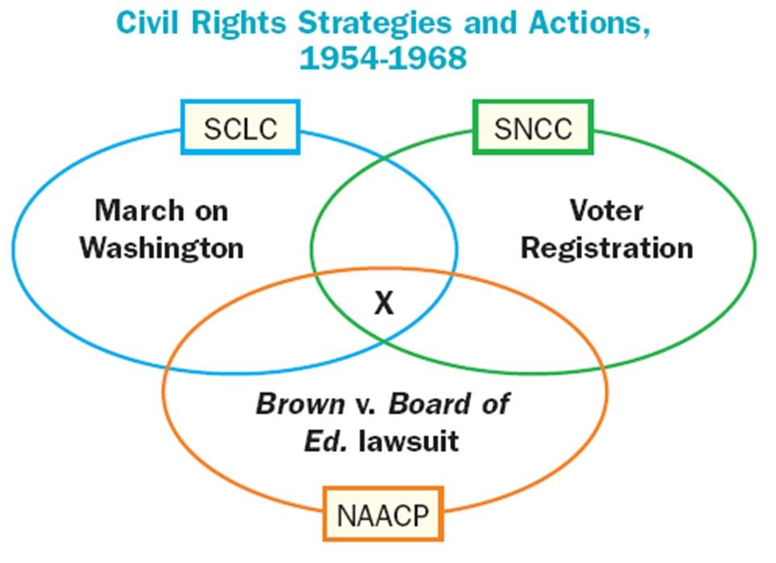
Brown v. Board of Education (1954) | ruled that segregation in public schools was unequal and thus unconstitutional. The decision reversed the previous ruling in Plessy v. Ferguson (1896).
Emmett Till’s Murder (1955) | Emmett Till's abduction and murder in Mississippi in August 1955, and the subsequent acquittal of his killers the following month
Montgomery Bus Boycott (1955) | A yearlong successful boycott after Rosa Parks refuses seat. Martin Luther King (Southern Christian Leadership Conference) gains status and proved blacks could unite.
Little Rock 9 (1957) | Arkansas high school integrated only after Eisenhower intervenes over government (State’s Rights?)
The Sit-In Movement  Feb 1960 | Four black students from North Carolina Agricultural and Technical College begin a sit-in at a segregated Woolworth's lunch counter.
Freedom Riders  May 1961 | Over the spring and summer, student volunteers begin taking bus trips through the South to test out new laws that prohibit segregation in interstate travel facilities, which includes bus and railway stations. Several of the groups of "freedom riders”
James Meredith  October 1962 | In the fall of 1962 James Meredith, a black, sought to be admitted to the all-white University of Mississippi. Violence and riots surrounding the incident cause President Kennedy to send 5,000 federal troops.
MLK Jr.  April 1963 | Martin Luther King is arrested and jailed during anti-segregation protests in Birmingham, Ala.; he writes his seminal "Letter from Birmingham Jail," arguing that individuals have the moral duty to disobey unjust laws.
March on Washington Aug. 28, 1963 | About 200,000 people join the March on Washington. Congregating at the Lincoln Memorial, participants listen as Martin Luther King delivers his famous "I Have a Dream" speech.
Civil Rights Act of 1964 (July 1964) | Forbade segregation in hotels, motels, restaurants, lunch counters, theaters, and sporting arenas that did business in interstate commerce. -- Equal Employment Opportunity Commission created to enforce the law.
Malcolm X assassinated  February 1965 | Rejecting integration and nonviolence, Malcolm splits off from Elijah Muhammad's Black Muslims and is killed by black opponents
TOP TEN AFRICAN AMERICAN LEADERS

Frederick Douglass (1818 to 1895)

Ida B. Wells (1862 to 1931)

Booker T. Washington (1865 to 1915)

W.E.B. DuBois (1868 t0 1962)

Marcus Garvey (1887 to 1940)

Dr. Martin Luther King Jr. (1929 to 1968)

Greensboro Four (1960)

Malcom X ( 1925 to 1965)

Stokley Carmichael (1941 to 1998)

Huey Newton (1942 to 1989)

Native American History
Confrontation, Forced Assimilation, reservations

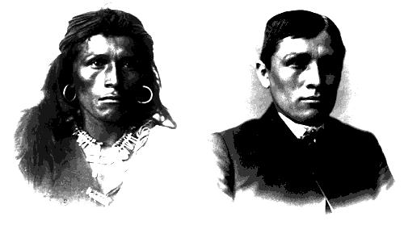
Pontiac's Rebellion (1763) | was a war launched in 1763 by North American Indians who were dissatisfied with British rule in the Great Lakes region after the British victory in the French and Indian War/Seven Years' War (1754–1763). Warriors from numerous tribes joined the uprising in an effort to drive British soldiers and settlers out of the region.
Trail of Tears | The Trail of Tears is a name given to the ethnic cleansing and forced relocation of Native American nations from southeastern parts of the United States following the Indian Removal Act of 1830.  A minority of the Cherokee tribe, despite the protest of the majority, had surrendered their Georgia land in the 1835 Treaty of New Echota. During the winter of 1838 - 1839, troops under General Winfield Scott evicted them from their homes in Georgia and moved them to Oklahoma Indian country. Many died on the trail; the journey became known as the "Trail of Tears".
Indian Schools  (1879–1918) | Forced Assimilation: The Carlisle Indian Industrial School The goal was to eliminate customs, rituals, and way of life of Native Americans Young children taught the white man’s way
Helen Hunt Jackson A Century of Dishonor (1881) | Author Helen Hunt Jackson researched led to opposition to government treatment of Native Americans. The solution was to make the Indians white. This policy destroyed Indians as a distinct nation.
Dawes Severalty Act (1887) | 160 acres given to family heads (Reservations) Conform to European land use patterns  private property as a cornerstone
Wounded Knee Massacre (1890) | Dec 29th. US troops massacred 300 POW. 20 congressional medals for honor for the seventh cavalry (most medals of honor given in US history, even WW2 and Vietnam) End of the Indian Wars
Women’s History
From the Cult of Domesticity to the Feminine Mystique

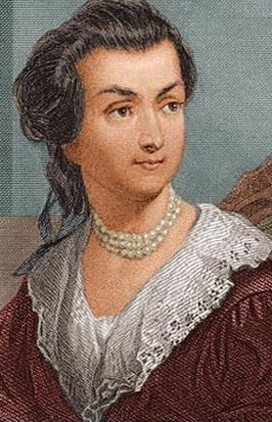  Abigail Adams | 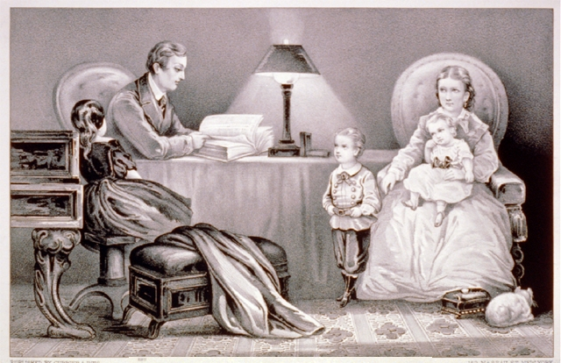  The Cult of Domesticity | 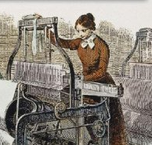  The Lowell System
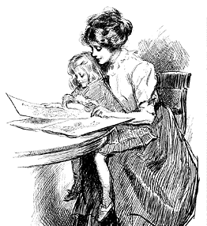  Republican Mothers | 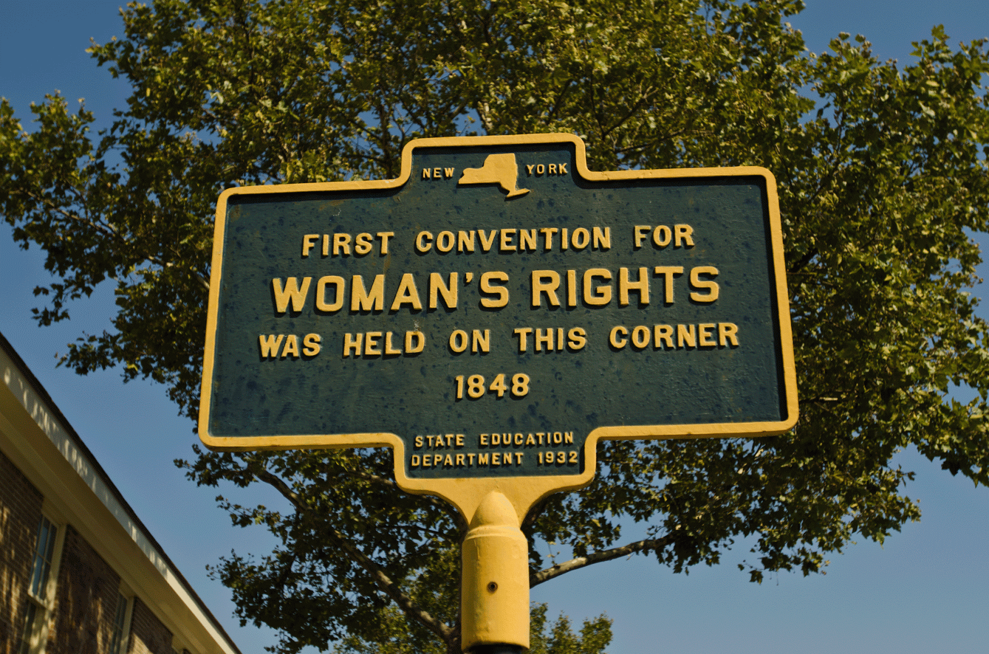  The Seneca Falls Convention | 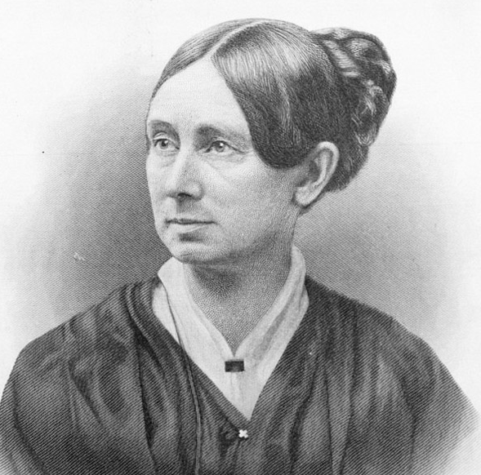  Dorothea Dix
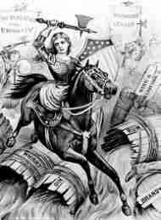  Women’s Christian Temperance Union | 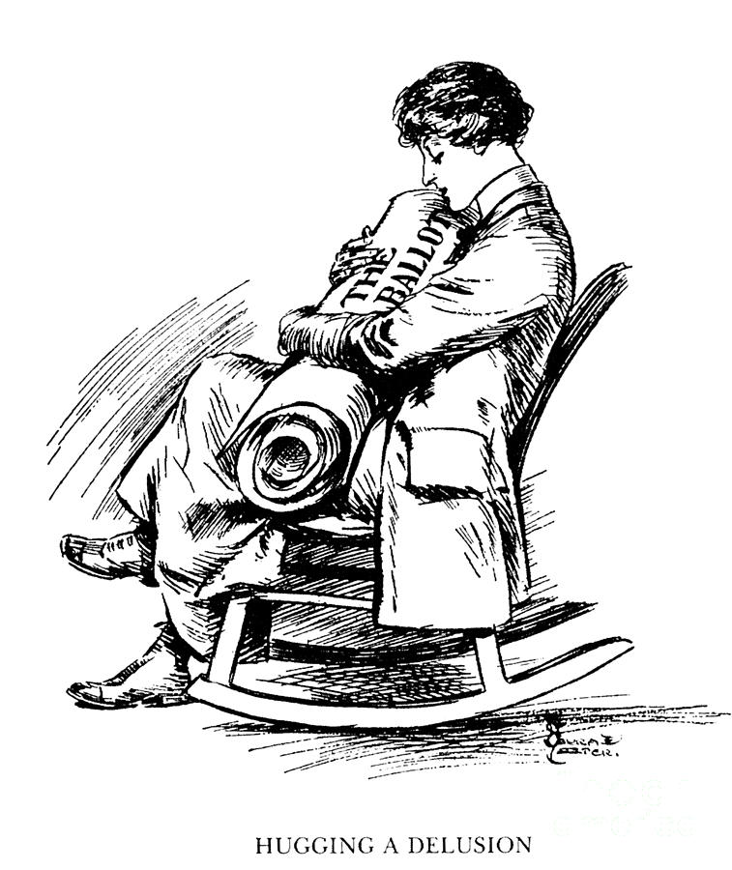  The Suffragettes – Part II | 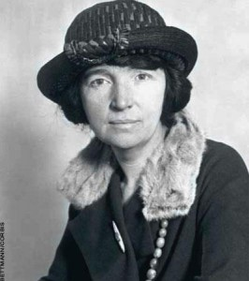  Margaret Sanger
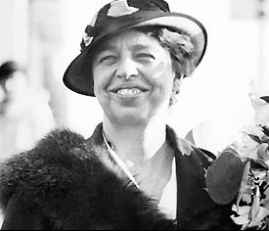  Eleanor Roosevelt |   Rachel Carson |   Betty Friedan

Women’s History 1607 – 1919
Cult of Domesticity to the 19th Amendment
Life in Colonial America | The importance of religion In New England, though, religion was central to all aspects of life; strict moral codes prevailed and anyone who disagreed with the established religious orthodoxy could be kicked out – ex. Roger Williams, who founded Providence, Rhode Island (1637) b/c he was exiled for promoting separation of church and state, and Anne Hutchinson.  Anne Hutchinson (antinomianism) and the "elect" didn’t need to obey God's or man's law because they were predestined for salvation. Antinomianism is the polar opposite of legalism, the notion that obedience to a code of religious law is necessary for salvation.
The Early Republic, 1789-1815 | Abigail Adams (March 1776) Asked husband John Adams to "remember the ladies" in an age when women were seen as strictly domestic. Do not put such unlimited power into the hands of the husbands. Remember all men would be tyrants if they could. If particular care and attention is not paid to the ladies, we are determined to foment a rebellion, and will not hold ourselves bound by any laws in which we have no voice or representation.
The Cult of Domesticity/Republican Motherhood | Woman’s status was beginning to change slightly, albeit perceptually. Mothers were looked upon as needing to raise children and instill republican ideals into them; this is known as Republican Motherhood.  According to the ideals of the cult of domesticity, women were supposed to embody perfect virtue in all senses. The women who abided by and promoted these standards were generally literate . Women were put in the center of the domestic sphere and were expected to fulfill the roles of a calm and nurturing mother, a loving and faithful wife, and a passive, delicate, and virtuous creature.
Women in Antebellum America, 1815-1860 | The Lowell System (The Waltham-Lowell System)  The system used domestic labor, often referred to as mill girls, who came to the new textile centers from rural towns to earn more money than was possible at home, and to live a cultured life in "the city". They lived a very regimented life - they lived in company boardinghouses and were held to strict hours and a rigid moral code.
Seneca Falls Convention, 1848 | Women began to find their collective voice and pushed for changes. The women’s rights movement got its start during this time, though it would be put off during the civil war and would not reach fruition until the early 20th century. Feminists met at Seneca Falls, New York in a Woman's Rights Convention in 1848 to rewrite the Declaration of Independence to include women. The two leading women of the movement were Elizabeth Cady Stanton and Susan B. Anthony.
The Women’s Christian Temperance Union (WCTU) 1873 | The purpose was to combat the influence of alcohol on families and society. They spearheaded the crusade for prohibition. Members in advanced their cause by entering saloons, singing, praying, and urging saloon keepers to stop selling alcohol.  Subsequently, on December 22, 1873. Caught up in the crusade, some states controlled, restricted, or abolished alcohol. They met with success but it was only temporary so by the next summer the women concluded that they must become organized nationally.
Women and Progressive Reforms | Most female progressives defended their new activities as an extension of their traditional roles of wife and mother.  A crucial focus for women's activism was the settlement house movement. Settlement houses exposed middle-class women to poverty, political corruption, and intolerable working and living conditions. CASE STUDY: Jane Addams and the Hull House
The fight for suffrage | Socially, the last two achievements of the Progressive Era occurred with the passage of the 18th and 19th amendments. The 18th amendment, prohibition, was passed in 1920 and made alcohol illegal in the United States. It was later repealed with the 21st amendment in 1933.  The 19th amendment passed in 1920 gave women the right to vote.

Women’s History 1920 to 1972
Cultural Liberation - Feminine Mystique - ERA

Boom and Bust, 1920 -1940 | The Flapper image of an emancipated young women is perpetuated in advertisements showcasing new fashions and attitudes that capture the free spirited twenties  Margaret Sanger led a birth-control movement.  Alice Paul formed the National Women's Party in 1923 to campaign for an Equal Rights Amendment to the Constitution.
World War II | The number of working women rose from 14,600,000 in 1941  to 19,370,000 in 1944 ( thirty-seven percent of all adult women were in the labor force)  Between 1940 and 1944, married women made up over seventy-two percent of the total number of female employees. By the end of the war, half of all female workers were over thirty-five.  Eleanor Roosevelt  Franklin D. Roosevelt's wife, Eleanor Roosevelt, was to become the most active First Lady in history. She powerfully influenced the policies of the national government, battling for the impoverished and oppressed.
1950s | The soldiers and their wives began the baby boom, perhaps the most prolific explosion of child births ever (in 1957 a baby was born every seven seconds!).  The new white-collar employment opened special opportunities for women. The baby boom during the years after World War II caused the role of women to revert to the typical role of a mother and wife. But the majority of the clerical and service work jobs created after 1950 were filled by women. Women's new dual role as both workers and homemakers raised urgent questions about family life and about traditional definitions of gender differences.
1963  The Feminine Mystique, | Feminist Betty Friedan published in helping to launch the modern women's movement. Friedan spoke to many educated women who supported her indictment of the boredom of a housewife.
The Equal Rights Amendment (ERA) | The Equal Rights Amendment, first proposed in 1923 to affirm that women and men have equal rights under the law, is still not part of the U.S. Constitution.  The ERA was passed out of Congress in 1972 and has been ratified by 35 of the necessary 38 states. When three more states vote yes, it is possible that the ERA could become the 28th Amendment. The ERA could also be ratified by restarting the traditional process of passage by a two-thirds majority in the Senate and the House of Representatives, followed by ratification by legislatures in three-quarters (38) of the 50 states.  The largest group to push for an Equal Rights Amendment (ERA) was women. They organized the National Organization of Women (NOW) to push for equal rights in the workplace. Women’s rights activists got a boost from the Supreme Court case of Roe v. Wade in which abortion was legalized

TOP TEN WOMEN REFORMERS

Abigail Adams (1774 to 1818)
Elizabeth Cady Stanton (1815 to 1902)
Sarah Moore Grimke (1792 to 1873)
Dorothea Dix (1802 to 1887)
Harriet Beecher Stowe (1811 to 1896)
Jane Addams (1860 to 1935)
Margaret Sanger (1879 to 1966)
Eleanor Roosevelt (1884 to 1962)
Rachel Carson (1907 to 1964)
Betty Freidan (1921 to 2006)
Reform Movements
Movements of Social Protest in American History
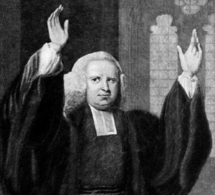  First Great Awakening | 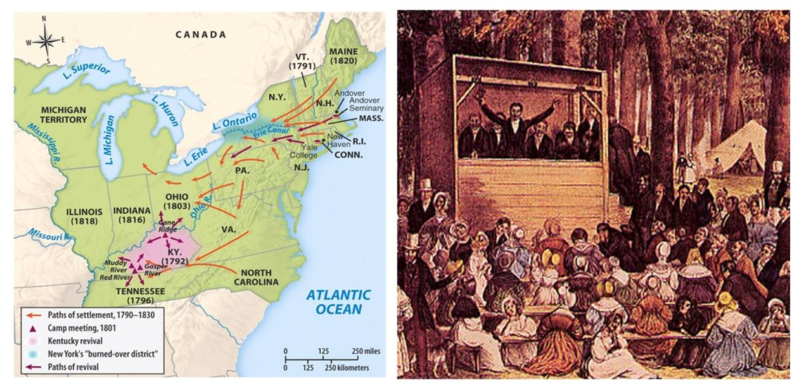  Second Great Awakening | The Seneca Falls Convention
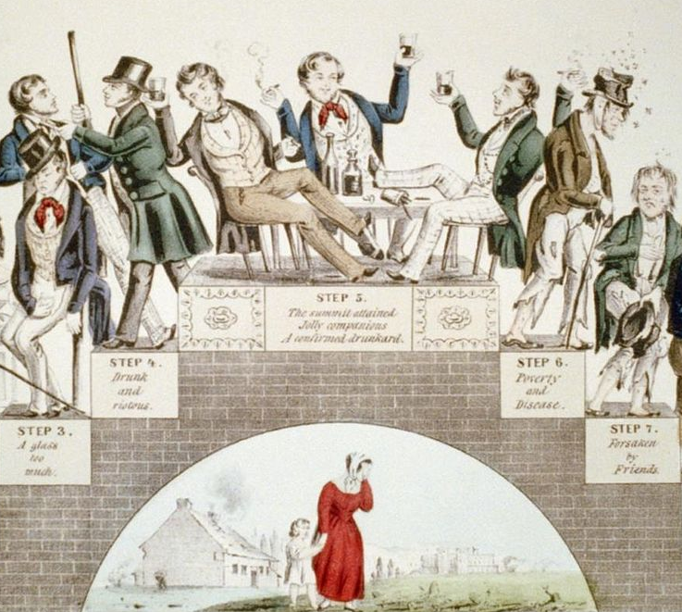  Temperance Movement | 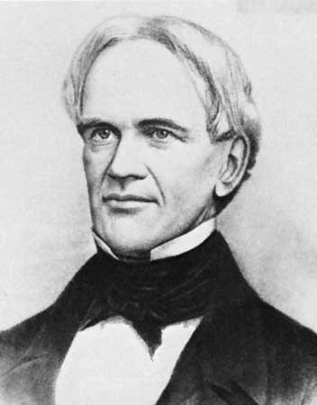  Education Reform | 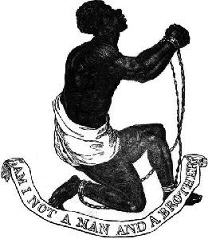  Abolition Movement
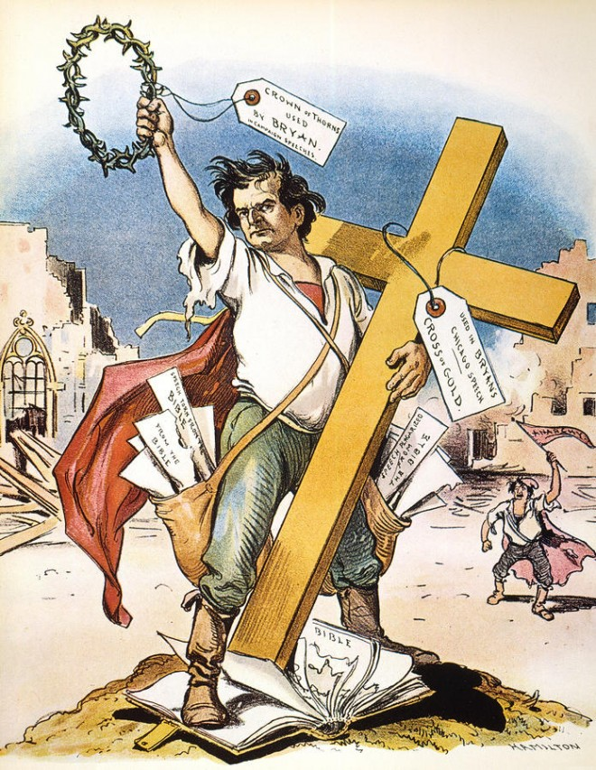  The Populist Movement | 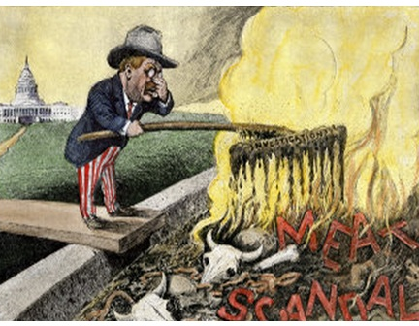  Progressive Reform | 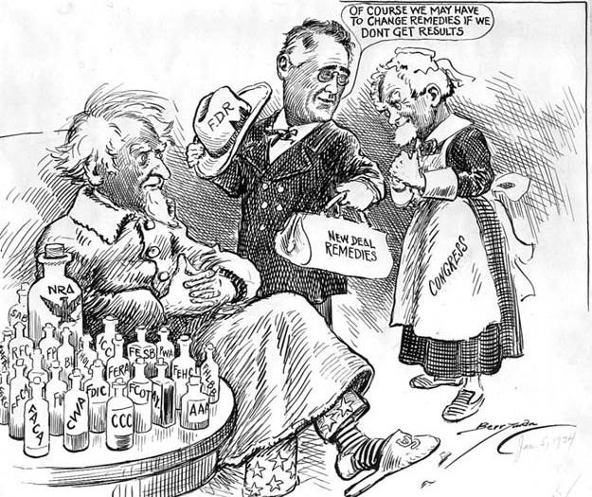  The New Deal
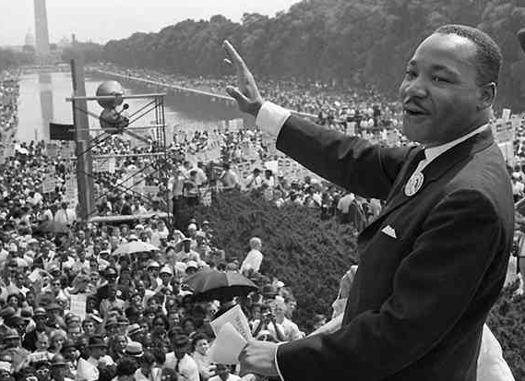  The Civil Rights Movement | 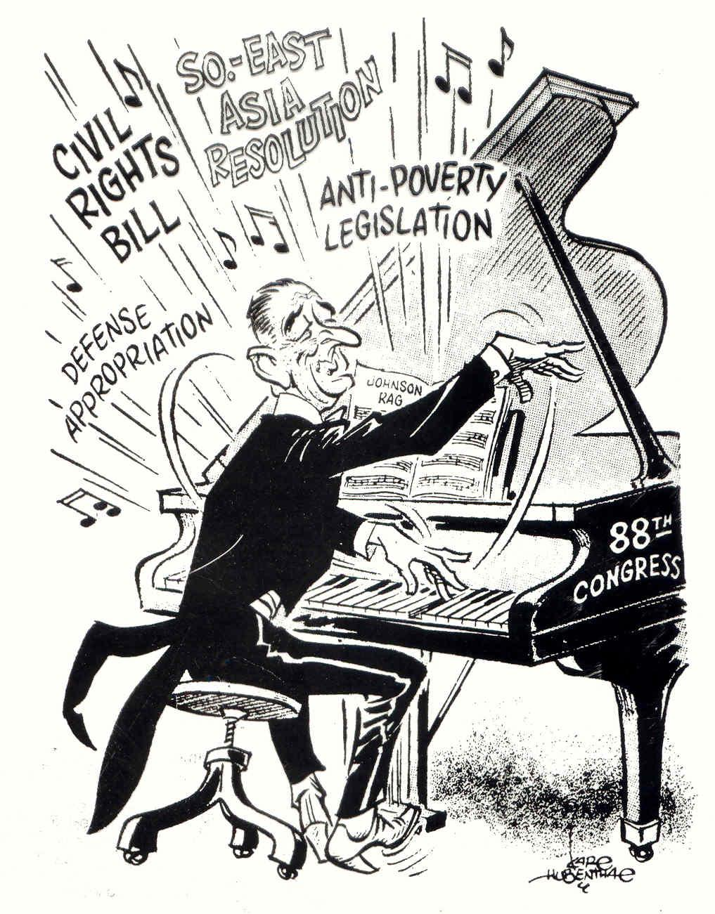  The Great Society | 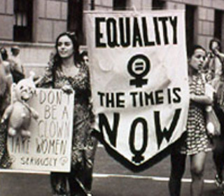  Woman’s Rights - ERA
Waves of Reform 1730 to 1860
Religious Revival and Reform
FIRST GREAT AWAKENING | SECOND GREAT AWAKENING
Religious Revival and Reform: The First Great Awakening (1730’s and 1740’s)  From the mid-1730s to the 1760s waves of religious revivalism swept through America. These revivalists were almost a counterpoint to the Enlightenment b/c they stressed feeling over rationalism. Religious revival in the colonies that was a reaction to liberal doctrine that stressed good works, the evils of Hell, God’s omnipotence and personal involvement  Notables: Jonathan Edwards, George Whitfield (the first modern celebrity), and Gilbert Tennant  Impact: Created a split in religion/churches between the “Old Lights” [traditionalists] and “New Lights” [revivalists]. More religious denominations, missionary zeal, and demand for more colleges to train them | Religious Revival and Reform: The Second Great Awakening (1790s – 1840s)  The wave of reform that swept America in the early nineteenth century was both a reaction to the radical changes American society experienced following the War of 1812 [immigration, market economy, expansion] and to the Second Great Awakening  Preachers encouraged sinners to repent and offered them a chance to become true Christians. Salvation was available for all through personal conversion. This philosophy increased lay participation, made religion more democratic, and led to efforts to reform society.  Notables: Reverend Thomas Weld, Charles Finney  Impact:. All the sects of the Second Great Awakening also shared a belief in self-improvement and the formation of organizations to help others convert.  Women were more involved in this than men were [though they often forced their husbands and families into it as well]. For women, revival meetings and reform societies offered unique opportunities for participation in public life and politics.

Revival, Reform in Antebellum America 1824 – 1845
“I know of no country, indeed where the love of money has taken stronger hold of the affections of man than in the United States. Still, man had it in his power to change because
he was endowed with an infinite faculty for improvement.”
Alex de Toqueville
REFORM | LEADER | CAUSES | GOAL
United States Temperance Union | Various | Excessive consumption of alcohol was widespread among all classes. | Abstinence from liquor including prohibition
Health | Dorothea Dix | Inhumane treatment of the insane in prisons: physical punishment & isolation | Prison Reform: Rehabilitation & treatment instead of punishment; build asylums
Women’s Rights - Seneca Falls Convention (1848) | Elizabeth Cady Stanton, Lucretia Mott | Lack of rights concerning property; suffrage; education. | Overcome inferior status with a focus on women’s suffrage
Education | Horace Mann | Concern for creating intelligent voters who could support & perpetuate democracy. | Free public education (tax-supported); longer school year; teacher training; broad curriculum
Abolition | Frederick Douglass, Sojourner Truth, William Lloyd Garrison, Harriet | Slavery as a moral wrong vs. white supremacy in the South | Emancipation (gradual by moderates, immediate by radicals)
Waves of Reform 1867 to 1920
Grassroots Reform – the Populists and Progressives
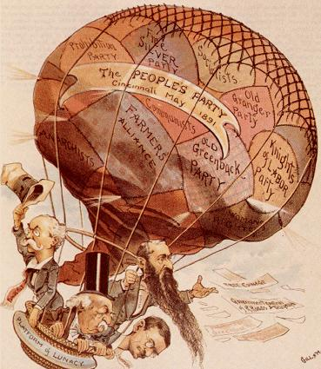 | 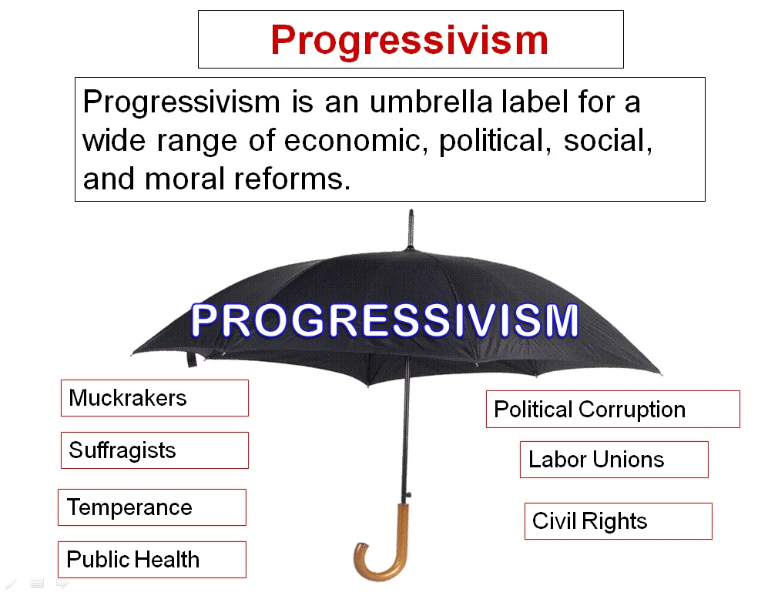
Populists | Progressives
- Formed in 1891 by remnants of the Farmers' Alliances.  - Big government party with a healthy list of demands that included:  - free coinage of silver,  - government ownership of the railroads, telegraphs, and telephone lines,  - graduated income tax,  - direct election of U. S. senators,  - the use of initiative, referendum, and recall  - The party eventually fades because farmers' situation improved in the late 1890s and because their political agenda was assumed by the major parties. | - Spanned the period 1900-1920 and the presidencies of three "Progressive" Presidents: Theodore Roosevelt (Republican), William Howard Taft (Republican), and Woodrow Wilson (Democrat).  - Believed that the laissez-faire system was obsolete, yet supported capitalism.  - Believed in the idea of progress and that reformed institutions would replace corrupt power.  - Applied the principles of science and efficiency to all economic, social, and political instituting.  - Viewed government as a key player in creating an orderly, stable, and improved society.  - Believed that government had the power to combat special interests and work for the good of the community, state, or nation.  - Political parties were singled out as corrupt, undemocratic, outmoded, and inefficient.  - Power of corrupt government could be diminished by increasing the power of the people and by putting more power in the hands of non-elective, nonpartisan, professional officials.

Waves of Reform 1930’s
FDR and The New Deal
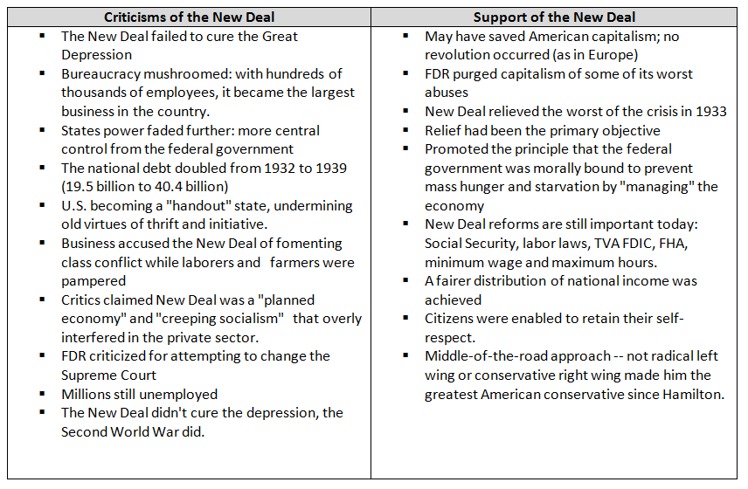
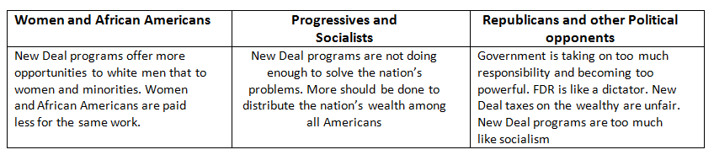
Waves of Reform - 1930’s
FDR and The New Deal
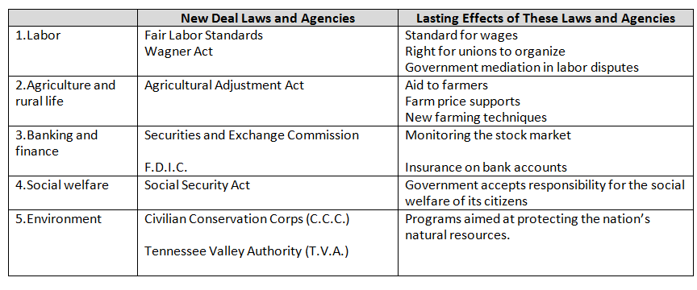
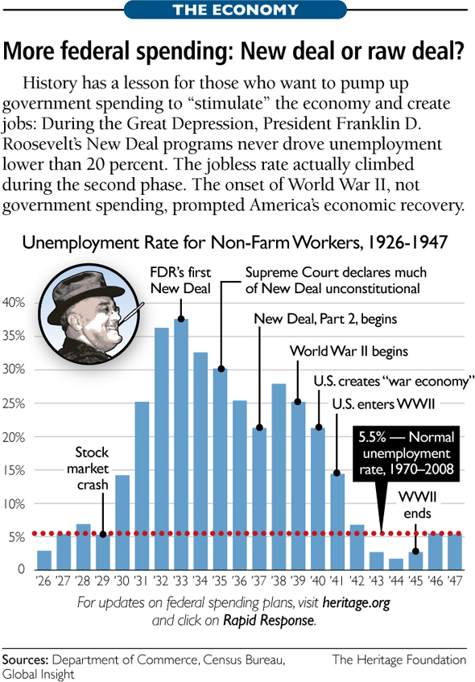

Waves of Reform - 1960’s
LBJ and The Great Society
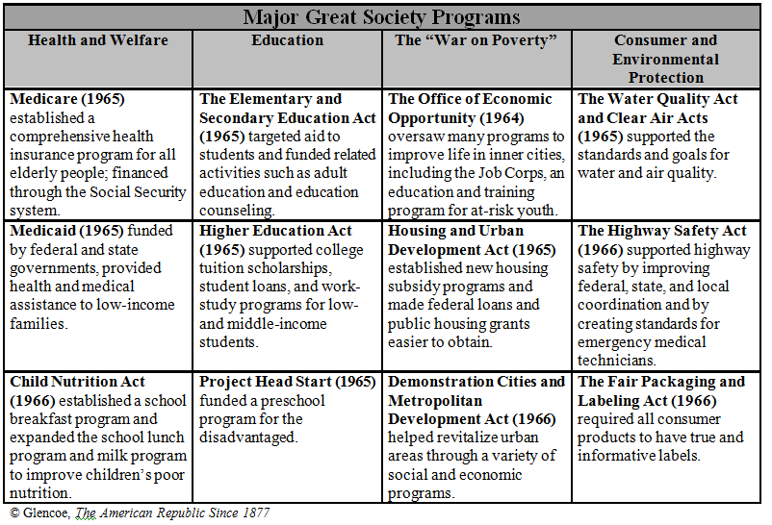

Similarities between the New Deal and the Great Society
#1 Both the New Deal and the Great Society used the government to enhance social welfare
#2 Both the New Deal and the Great Society included the following:
- Government sponsored employment programs
- Government support of the arts
- Federal programs to encourage housing construction
- Federal legislation to help the elderly
Differences between the New Deal and the Great Society
#1 Preschool education for disadvantaged children was an innovative Great Society Program. This was not an extension of the New Deal
#2 In contrast to the New Deal, The Great Society included federal legislation protecting civil liberties of African American

American Government
Role and Function of Gov’t, Political Parties and Branches in Action

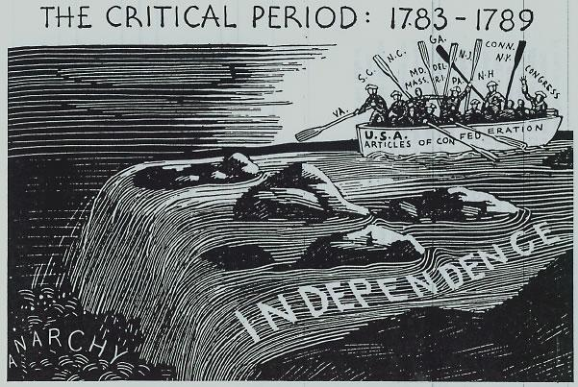  The Articles of Confederation | 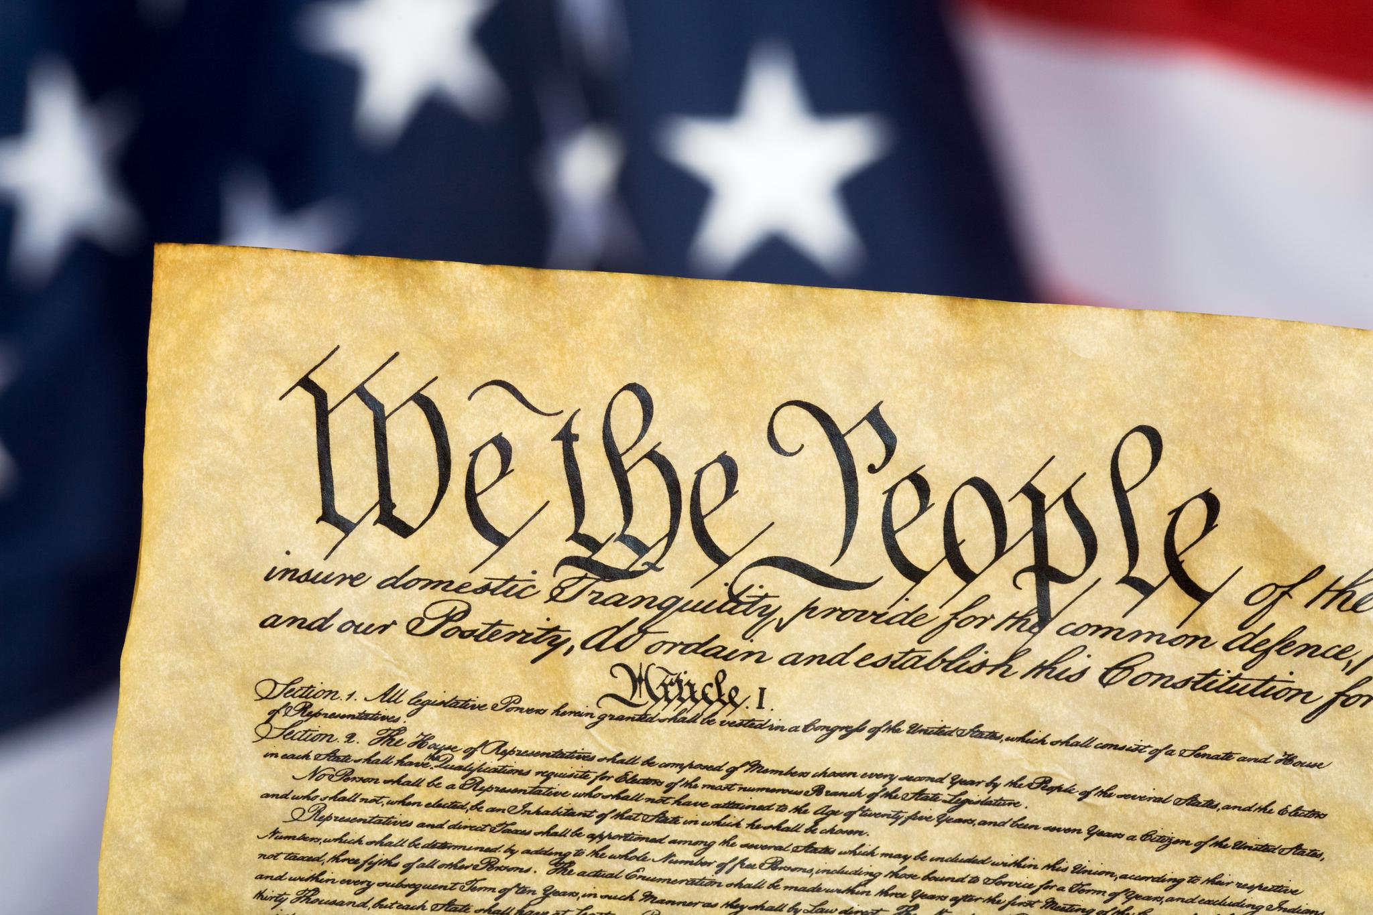  The US Constitution | 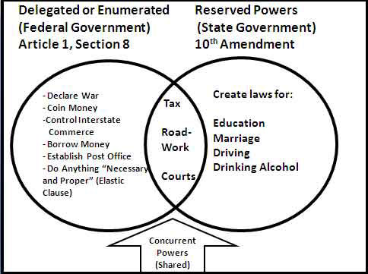  Key Constitutional Principles
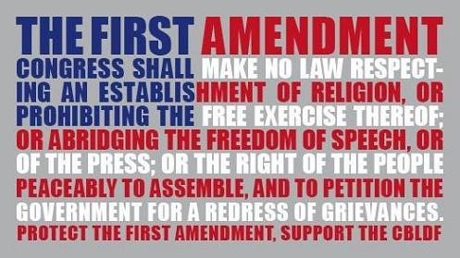  Key Amendments | 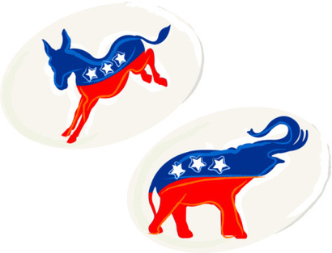  Time Line of Political Parties | 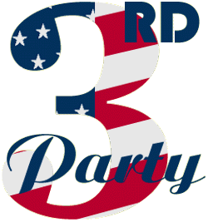  Third Parties in US History
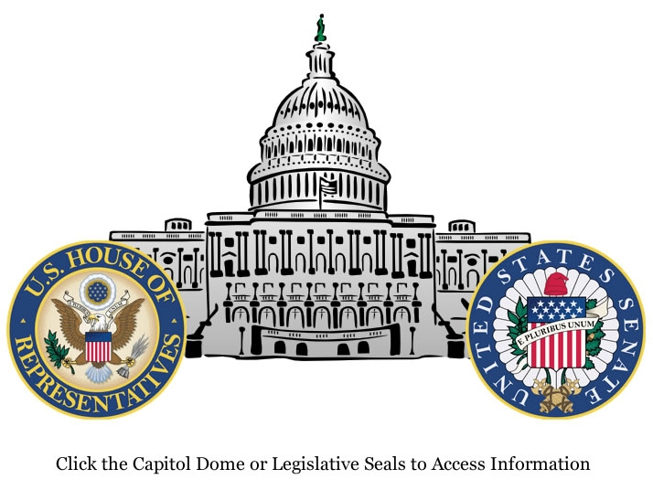  The Legislative Branch | 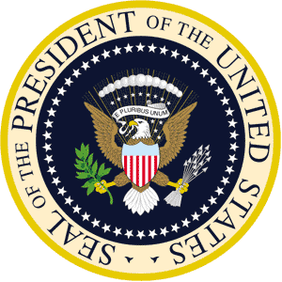  The Executive Branch | 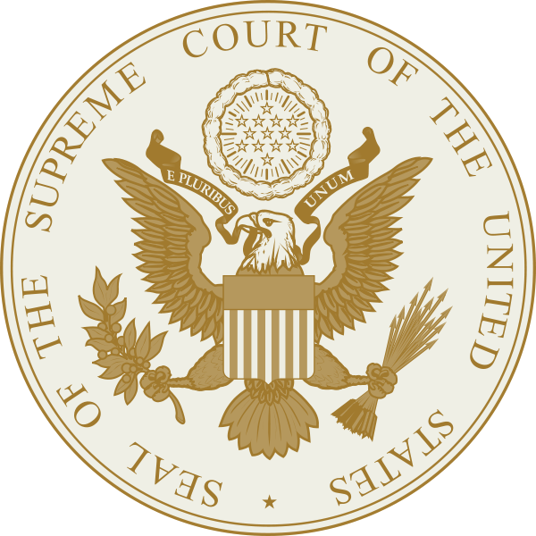  The Judicial Branch
American Government Review
Weaknesses of the Articles of Confederation

Weaknesses | Consequences
No Chief Executive – Congress used committees to  Get their work accomplished | No one leader to organize things, no one person for a  foreign nation to deal with, committees didn’t  work well together
Passing a law took approval of 9 of the 13 states | With 5 “small” and 8 “large” states it was almost impossible to get an agreement, delegates from all states weren’t around very often
Amending the document required approval of 13 of the 13 states | This never happened, so even when changes were needed, they couldn’t happen
Congress could request the states pay taxes, but they couldn’t force them to pay. Congress could borrow money. | Most states had debts of their own and were slow to pay the requested amount if they paid it at all. Congress borrowed money from foreign nations, but all that did was increase our national debt
Congress possessed no power to control commerce – foreign or domestic | Made it difficult for nations to trade with the US because of the different state regulations. Congress had no power to protect US industries with duties.
Congress could make treaties but had no power to require the states to follow them | Couldn’t force the states to live up to the Treaty of Paris
Congress could make laws but had no power to force the states to abide by them | They could ask, but they couldn’t force. So if a law had been passed the 4 states that disagreed could just not follow it
No National court system | No way to settle disputes between states
Success of the Articles??
American Government Review
Federalism and Separation of Powers

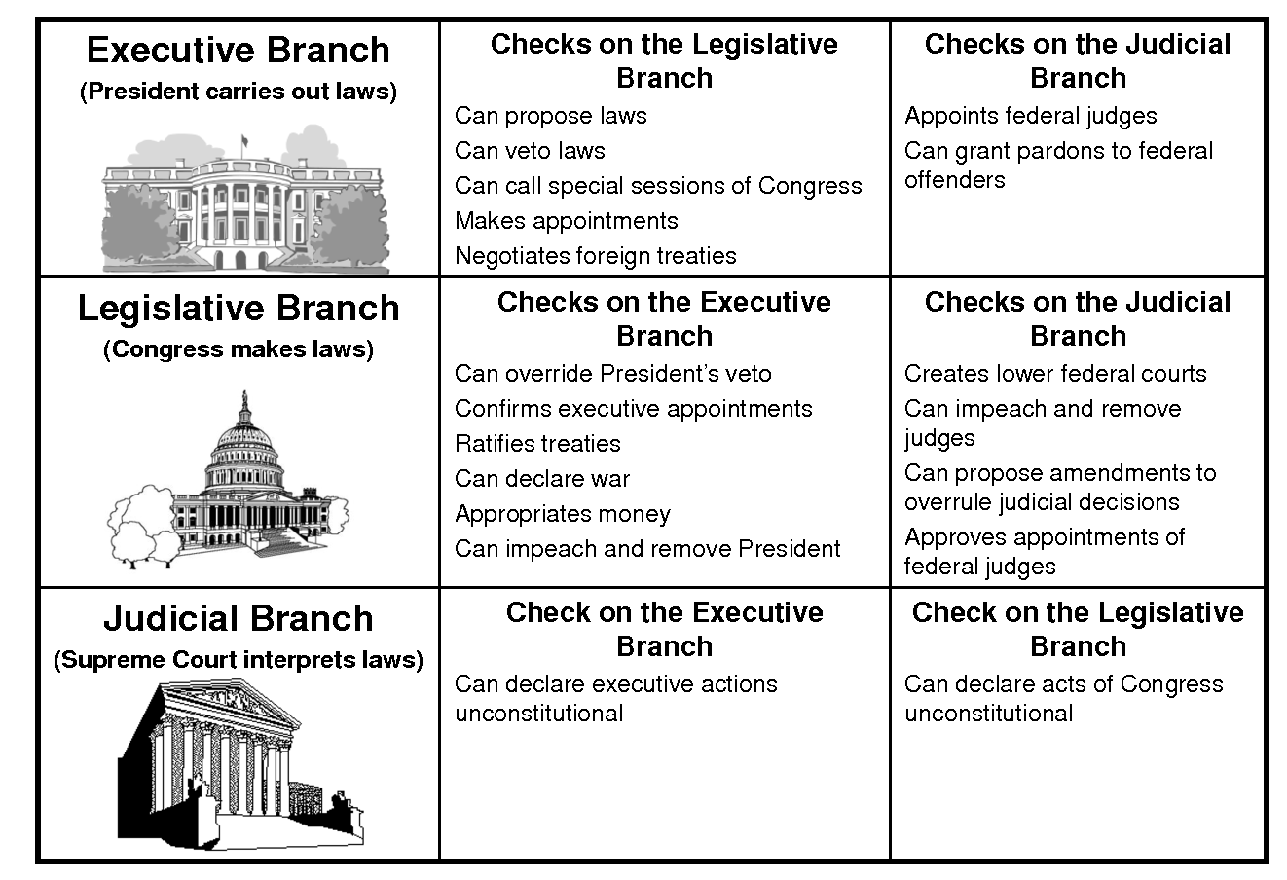
American Government Review
Amendments to U.S. Constitution
1 | Prohibits federal government from restricting religion, speech, assembly, petition, press
2 | Gives citizens right to bear arms
3 | Prohibits federal government from housing troops in private homes during peacetime
4 | Prohibits federal government from making unreasonable searches and seizures
5 | Prohibits double jeopardy, self-incrimination, seizing property without due process, and just compensation
6 | Citizens have right to speedy and public trial, be informed of charges against them, impartial jury, legal counsel
7 | Citizens have right to a jury trial
8 | Prohibits excessive bail or fines and cruel or unusual punishment
9 | Rights not enumerated in Constitution remain in people’s hands
10 | Powers not delegated to federal government are reserved to the state or people
11 | Federal courts have no authority in suits by citizens against another state or foreign states
12 | Provides for separate electoral voting for president and vice president
13 | Abolished slavery in the United States | Civil War Amendments
14 | Blacks given citizenship; all citizens guaranteed due process of law and equal protection of the law; federal government would protect rights if states failed to do so | 13, 14, 15
15 | Black men given the right to vote
16 | Federal government allowed to tax incomes | Progressive Era Amendments
17 | Direct popular election of United States senators
18 | Prohibited the manufacture, sale, and transportation of alcoholic beverages
19 | Women given the right to vote
20 | Congress begins new term on January 3; president and vice president begin terms on January 20 of year following their election
21 | Repealed Eighteenth Amendment
22 | Limited the president to two terms or ten years in office
23 | District of Columbia given three electoral votes in presidential elections
24 | Abolished poll taxes in the voting process
25 | When president dies or is disabled, vice president becomes president and new vice president is appointed; established procedures in case of presidential disability
26 | All citizens eighteen years of age and older given right to vote
27 | Congress prohibited from changing its pay for the current congressional term
American Government
The History of Political Parties in the United States
Faction: A political faction is a grouping of individuals, especially within a political organization, such as a political party, a trade union, or other group with a political purpose. It may also be referred to as a power bloc, or a voting bloc. The individuals within a faction are united in a common goal or set of common goals for the organization they are a part of, not necessarily shared by all of that organization's members. They band together as a way of achieving these goals and advancing their agenda and position within the organization.
A political faction could thus be described as a “party within a party”. However, political factions are not limited to political parties; they can and frequently do form within any group that has some sort of political aim or purpose.
Federalists v. Anti-Federalists 1787-1789
Federalist: | Anti-Federalist
Statesmen and public figures supporting ratification of the proposed Constitution of the United States between 1787 and 1789. The Federalist Papers are documents associated with their movement. | Anti-Federalist: refers to a movement that opposed the creation of a stronger U.S. federal government and which later opposed the ratification of the Constitution of 1787. The previous constitution, called the Articles of Confederation, gave state governments more authority. Led by Patrick Henry of Virginia, Anti-Federalists worried, among other things, that the position of president, then a novelty, might evolve into a monarchy. Also, were advocates of a Bill of Rights.
Federalist Party: 1789-1820
The Federalist Party: an American political party in the period 1792 to 1816, with remnants lasting into the 1820s. The Federalists controlled the federal government until 1801. The party was formed by Alexander Hamilton, who, during George Washington's first term, built a network of supporters, largely urban, to support his fiscal policies. These supporters grew into the Federalist Party, which wanted a fiscally sound and strong nationalistic government and was opposed by the Democratic-Republicans (or Jeffersonian Republicans). While George Washington never joined the party, he often sided with them on key issues of the day. The United State's only Federalist elected president was John Adams. At this time the Federalist became strong supporters of British trade which would ultimately lead to their downfall at the Hartford Convention 1814, where they decided to protest the Republican-backed War of 1812.
Jeffersonian Republicans (Democratic-Republicans) 1792-1824; c 1824-present
The Democratic–Republican Party: founded by Thomas Jefferson and James Madison about 1792. Supporters usually identified themselves as Republicans, but sometimes as Democrats. It was the dominant political party in the United States from 1800 to 1824, (commonly known as the Era of Good Feelings), when it split into competing factions, one of which became the modern Democratic Party (1824- Andrew Jackson).
The National Republicans: 1820-1833. A faction of Jefferson’s party, led by Henry Clay of Kentucky and John C. Calhoun of South Carolina. Unlike the Democratic-side of the party, which sponsored States’ Rights, they advocated national programs to improve the United States. (The American System)
The Democratic Party: 1824-present. The Democratic-Republican party split into various factions during the 1824 election, based more on personality than on ideology. When the election was thrown to the House of Representatives, House Speaker Henry Clay backed Secretary of State John Quincy Adams to deny the presidency to Andrew Jackson, a longtime personal rival and a hero of the War of 1812. This event became characterized by Jackson supporters as the “Corrupt Bargain.” At first, the various factions continued to view themselves as Republicans. Jackson's supporters were called "Jackson Men," while Adams supporters were called "Adams Men."
Democratic-Republican Presidents: Thomas Jefferson, James Madison, James Monroe, John Quincy Adams, Andrew Jackson, Martin Van Buren, James Polk, Franklin Pierce, James Buchanan, Grover Cleveland, Woodrow Wilson, Franklin Roosevelt, Harry Truman, John Kennedy, Lyndon Johnson, Jimmy Carter, William Clinton, Barack Obama.
The Whig Party 1833-1856
The Whig Party: a political party of the United States during the era of Jacksonian democracy. Considered integral to the Second Party System and operating from 1833 to 1856, the party was formed in opposition to the policies of President Andrew Jackson and the Democratic Party. In particular, the Whigs supported the supremacy of Congress over the Executive Branch and favored a program of modernization and economic protectionism. Their name was chosen to echo the American Whigs of 1776, who fought for independence, and because "Whig" was then a widely recognized label of choice for people who saw themselves as opposing autocratic rule. The Whig Party counted among its members such national political luminaries as Daniel Webster, William Henry Harrison, and their preeminent leader, Henry Clay of Kentucky. In addition to Harrison, the Whig Party also counted four war heroes among its ranks, including Generals Zachary Taylor and Winfield Scott. Abraham Lincoln was a Whig leader in frontier Illinois.
Whig Presidents: William Henry Harrison, John Tyler, Zachary Taylor and Millard Fillmore.

The Evolution of Political Parties 1828 to 1860
Disputes over slavery in the territories first erode, then destroy what had become America's second two-party system.
The erosion began in the 1840s as various factions opposed to the post-Jackson Democratic political coalition begin to form.
 | Party #1 | Third Party /Splinter Parties | Party #2
1828 |  |  | Democrats  Andrew Jackson
1832 |  | . | Democrats  Andrew Jackson
1836 |  | The Whig Party  Henry Clay (Candidate)  formed out of the National Republican Party, nationalists, supported internal improvements and moral reforms, and desired gradual westward expansion in congruence with economic growth and modernization | Democrats  Martin Van Buren
1840 | Whigs  William Harrison  (President – dies in office)  John Tyler  (VP takes over) | Liberty Party  James C. Birney (Candidate)  Anti-slavery party - Radicals followed William Lloyd Garrison, the conservatives sought to end slavery gradually
1844 | Whigs  Henry Clay (Candidate) | Liberty Party  James C. Birney (Candidate) | Democrats  James K. Polk
1848 | Whigs  Zachary Taylor  (President – dies in office)  Millard Fillmore  (VP takes over) | Free Soil Party  Martin Van Buren (Candidate)  absorbed men from the Liberty Party "Conscience," or anti-slavery, Whigs; and "Barnburner" Democrats, whose anti-black prejudices allied them with anti-slavery men. | Democrats  Lewis Cass (Candidate)
1852 | Whigs:  Winfield Scott  (Candidate)  Because the Whigs did not come out as vehemently pro-slavery some Southern Whigs deserted the party to join the Democrats. | Free Soil Party:  John P. Hale (Candidate)  Demanded the repeal of the Fugitive Slave Law and opposed the further admission of slave states | Democrats  Franklin Pierce
1856 | Republicans  John Fremont (Candidate) | American Party:  Millard Fillmore (Candidate)  Many nativists feared foreign invasion. Organized a secret order known as the "Know-Nothings" or the "Order of the Star Spangled Banner" | Democrats  James Buchanan
1860 | Republicans  Abraham Lincoln | Liberty Party, Free Soil Party, Know-Nothing Party and former Whigs form the Republican Party | Southern Democrats | Northern Democrats

The Election of 1860

Democrats | Republicans
- Split at its 1860 Convention in Charleston, South Carolina when a platform defending slavery was defeated and Deep South delegates walked out.  - At a splinter convention held at Baltimore, Maryland, Stephen Douglas of Illinois was nominated as presidential candidate on a platform opposing any Congressional interference with slavery..  Southern delegates met and nominated John Breckenridge of Kentucky as a candidate on a pro-slavery platform. | - The Republicans, by this time a overtly sectional and decidedly opposed to slavery draw in most northerners with a platform favoring a homestead act, a protective tariff, and transportation improvements.  - The platform opposed the extension of slavery but defended the right of states to control their own "domestic institutions."  Abraham Lincoln is nominated presidential candidate on the third ballot.

The Pallid Politics of the Gilded Age
Republicans & Democrats, Democrats and Republicans
- Party differences blur during this period with loyalties determined by region, religious, and ethnic differences.
- Voter turnout for presidential elections averaged over 78 percent of eligible voters; 60 to 80 percent in non-presidential years.
- Both parties were pro-business.
- Both parties were opposed to any type of economic radicalism or reform.
- Both parties advocated a "sound currency" and supported the status quo in the existing financial system.
- Federal government and, to some extent, state governments tended to do very little.
- Republicans dominate the Senate; Democrats dominate the House of Representatives.
- Republican Party splinter groups during this period: Stalwarts, Halfbreeds, Mugwumps.

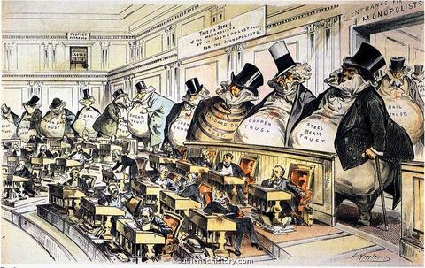
The Populist Party | The Progressive Party
Formed in 1891 by remnants of the Farmers' Alliances.  Big government party with a healthy list of demands that included:  - free coinage of silver,  - government ownership of the railroads, telegraphs, and telephone lines,  - graduated income tax,  - direct election of U. S. senators,  - the use of initiative, referendum, and recall  The party eventually fades because farmers' situation improved in the late 1890s and because their political agenda was assumed by the major parties. | Spanned the period 1900-1920 and the presidencies of three "Progressive" Presidents: Theodore Roosevelt (Republican), William Howard Taft (Republican), and Woodrow Wilson (Democrat).  Believed that the laissez-faire system was obsolete, yet supported capitalism.  Believed in the idea of progress and that reformed institutions would replace corrupt power. Applied the principles of science and efficiency to all economic, social, and political instituting.  Viewed government as a key player in creating an orderly, stable, and improved society. Believed that government had the power to combat special interests and work for the good of the community, state, or nation.  Political parties were singled out as corrupt, undemocratic, outmoded, and inefficient.  Power of corrupt government could be diminished by increasing the power of the people and by putting more power in the hands of non-elective, nonpartisan, professional officials.

The progressives eventually co-opt many of the Populist demands such as referendum, initiative, direct election of Senators, etc. Some of these are incorporated in the "Progressive" Amendments to the U. S. Constitution: 16th, 17th, 18th, and 19th Amendments.

The Republican Era
- From 1921 to 1933 both the presidency and congress were dominated by Republicans (Presidents Harding, Coolidge, and Hoover).
- The position of the government was decidedly pro-business.
- Though conservative, the government experimented with new approaches to public policy and was an active agent of economic change to respond to an American culture increasingly urban, industrial, and consumer-oriented.
- Conflicts surfaced regarding immigration restriction, Prohibition, and race relations.
- Generally, this period was a transitional one in which consumption and leisure were replacing older "traditional" American values of self-denial and the work ethic.

The Political Legacy of the New Deal (1933-1952)
- Created a Democratic party coalition that would dominate American politics for many years (1933-1952).
- Included ethnic groups, city dwellers, organized labor, blacks, as well as a broad section of the middle class.
- Awakened voter interest in economic matters and increased expectations and acceptance of government involvement in American life.
- The New Deal coalition made the federal government a protector of interest groups and a mediator of the competition among them.
- "Activists" role for government in regulating American business to protect it from the excesses and problems of the past.
- Fair Deal of the post-war Truman administration continued the trend in governmental involvement: i.e. advocated expanding Social Security benefits, increasing the minimum wage, a full employment program, slum clearance, public housing, and government sponsorship of scientific research.
- In 1948, the "liberal" or Democratic coalition split into two branches: State’s Rights and the Progressive wing:
States' Rights | Progressive Party
- Southern conservative Democrats known as "Dixiecrats."  - Opposed the civil rights plank in the Democratic platform.  - Nominated South Carolina Governor Strom Thurmond for President. | - "Liberal" Democrats who favored gradual socialism, the abolition of racial segregation, and a conciliatory attitude toward Russia.  - Nominated Henry A. Wallace for president.

Post-World War 2 Politics
Democrats | Republicans
- The Democrats maintain what by this time had become their "traditional" power base of organized labor, urban voters, and immigrants.  - In the 1952 election, the Democrats run Illinois Governor Adlai Stevenson, a candidate favored by "liberals" and intellectuals.  - As the post-World War 2 period progresses, the Democratic Party takes "big government" positions advocating larger roles for the federal government in regulating business and by the 1960s advocate extensive governmental involvement in social issues like education, urban renewal, and other social issues.  - The Democratic Party very early associates itself with the growing civil rights movements and will champion the Civil Rights Act and the Voting Rights Act. |  | - In 1952, the pro-business Republican Party ran General Dwight D. Eisenhower for president.  - The Republicans accuse the Democrats of being "soft" on communism.  - Republicans promise to end the Korean War.  - Conservative Southern Democrats, the "Dixiecrats," increasingly associate themselves with Republican candidates who oppose civil rights legislation.

Nixon's New Federalism
Democrats | Republicans
- The Democratic Party by the late 1960s is deeply fragmented and seemingly incapable of dealing with the violence and turmoil, social and political, caused by the Vietnam War.  - In 1968, the Democratic Party candidate is Vice President Hubert Humphrey.  - In the post-Vietnam War period, Democrats advocate a range of "liberal" social issues including the extension of civil rights, support for "reproductive rights" (i.e. birth control and abortion rights), fair housing legislation, etc. | - Opposition to the War in Vietnam and to growing federal social programs "converts" southern Democrats to vote Republican in increasing numbers.  - Republicans run former Vice President Richard Nixon for president in 1968. He runs on a small-government, anti-war campaign as a defender of the "silent majority."  - Nixon advocated a policy of cutting back Federal power and returning that power to the states. This was known as the "New Federalism."

Reagan and the "New Right"
Democrats | Republicans
- Strongly support environmental legislation, limiting economic development, halting the production of nuclear weapons and power plants.  - Pro-choice movement emerged during the 1980s to defend a woman's right to choose whether and when to bear a child.  - Affirmative Action, the use of racial quotas to "balance" the workforce, to one degree or another, becomes an issue of political disagreement with Democrats favoring it and Republicans opposing it. | - Fueled by the increasingly "liberal" social agenda of the Democrats and spurred on by the rise of a militant and extremely well-organized Evangelical Christianity, most southern states begin voting Republican in considerable majorities.  - Conservative Christians, Southern whites, affluent ethnic suburbanites, and young conservatives form a "New Right" that supported Ronald Reagan in 1980 on a "law and order" platform that advocated  - stricter laws against crime, drugs, and pornography,  - opposition to easy-access abortions,  - and an increase in defense spending,  - a cut in tax rates  - While Reagan curbed the expansion of the Federal Government, he did not reduce its size or the scope of its powers.

The Legislative Branch
Legislative Landmarks that Shaped U.S. History
Congress isn’t always mired in gridlock, squabbling, and scandal. Crises such as the looming Civil War, the Great Depression, and the civil rights movement have sparked “the people’s representatives” to pass some of the nation’s boldest legislation. Whether products of bipartisan cooperation or bitter struggle, these then acts of Congress have built America. ..

LOUISIANA PURCHASE (1803) | With the American landgrab of the nineteenth century under way, President Thomas Jefferson hoped to purchase from France nearly 830,000 square miles between the Mississippi and the the Rockies for $15 million. That’s about three cents an acre. A constitutional provision might have barred the federal government from buying foreign territory, but the Senate, accepting Jefferson’s broad interpretation of the provision, approved the purchase. The House appropriated the money to consummate the deal. On December 20, 1803, the U.S. took possession of North America’s heartland, doubling the nation’s size with territory that would comprise 13 states. The purchase allowed settlement westward and tapped natural resources that would help the U.S. emerge as a world power.
KANSAS-NEBRASKA ACT (1854) | Should slavery be extended into the United States’ new territories Kansas and Nebraska? The Kansas-Nebraska Act turned the question over to popular vote. When the act passed, thousands of settlers from both sides of the issue flooded Kansas, the territory where slavery status was most in question. by October 1856, 200 people had died during fighting in “bleeding Kansas.” The battle hardened North-South divisions and made civil war all but inevitable. But in the long run, the act forced the nation to address the poisonous legacy of one race enslaving another.
HOMESTEAD ACT (1862) | The Civil War–era legislation allowed any family head or adult male to claim 160 acres of prairie land for a $10 registration fee and a promise to live there continuously for five years. It opened up 83 million acres for immediate settlement and added 15 million acres later. Between 1863 and 1880, over half of the 242,000 new farms in Minnesota, the Dakota Territory, Nebraska, and Kansas were homesteading ventures. The act drew thousands of English, Irish, Germans, Swedes, Danes, Norwegians, and Czechs to the U.S., pushing settlement farther west.
SOCIAL SECURITY ACT (1935) | The act was designed to secure “the men, women, and children of the nation against certain hazards and vicissitudes of life,” explained President Franklin Roosevelt. The act’s best-known measure is the social insurance system that provides monthly checks to the elderly. The government issued the first Social Security check on January 31, 1940, to Ida May Fuller of Ludlow, Vermont, in the amount of $22.54. Since then, Uncle Sam has paid out over $4 trillion, and in 1997, one in seven Americans received Social Security benefits.
NATIONAL LABOR RELATIONS ACT (1935) | In the 1930s, a steelworker needed to labor for an hour and a half to earn enough money to purchase a dozen eggs. Today, an average union worker can pay for the eggs after seven minutes on the job. By declaring that workers had a right to join unions and bargain collectively with employers for pay raises, the act is responsible for this increased purchasing power. Labor’s Magna Carta also provided workers with the legal weapons to improve plant conditions and protect themselves from employer harassment.
LEND-LEASE ACT (1941) | A program under which the United States supplied Great Britain, the USSR, Free France, the Republic of China, and other Allied nations with materiel between 1941 and August 1945. It was signed into law on March 11, 1941, a year and a half after the outbreak of World War IIin Europe in September 1939 and nine months before the U.S. entered the war in December 1941.
G.I. BILL OF RIGHTS (1944) | What do Gerald Ford, George Bush, Paul Newman, Clint Eastwood, David Brinkley, and Jason Robards have in common? They all benefited from the G.I. Bill of Rights, known officially as the Servicemen’s Readjustment Act of 1944. The law, which was later amended to include all veterans, originally guaranteed a year of college or trade education to ex-World War II servicemen with at least 90 days in the armed forces. It also mandated that they receive up to $500 a year for tuition, books, and supplies. Of the nearly 8 million veterans who took advantage of this first G.I. bill, 450,000 became engineers, 240,000 accountants, 238,000 teachers, 67,000 doctors, and 22,000 dentists, while thousands more chose other professional careers. Veterans also made use of the bill’s guaranteed mortgages and low interest rates to buy new homes in the suburbs, kicking off a development boom.
TRUMAN DOCTRINE (1947) | As a result of growing tensions between the U.S. and the Soviet Union after World War II, the Truman Doctrine called for $400 million in U.S. aid for Greece and Turkey to loosen the communist grip on those countries and to promote democracy and capitalism. But the legislation’s key significance lay in the language that President Harry Truman used to sway Congress to pass the bill. Convinced by advisers that he needed to build support by “scaring the hell out of the country,” Truman declared to a joint session of Congress, “I believe that it must be the policy of the United States to support free peoples who are resisting attempted subjugation by armed minorities or by outside pressures.” Truman’s rhetoric transformed the Cold War into a moral conflict in which any change in the international political climate was perceived as a threat to U.S. interests. The country became locked in an arms race; anti-communist hysteria ensued and gave ammunition to demagogues like Joseph McCarthy. But there is also the argument (most often put forth by conservatives) that the Truman Doctrine presaged U.S. victory in the Cold War and the collapse of the Berlin Wall.
 | FEDERAL HIGHWAY ACT (1956) “More than any single action by the government since the end of the war, this one would change the face of America,” said President Eisenhower, years later, about his administration’s biggest achievement. One of the most expensive public-works projects in U.S. history, the highway act allocated more than $30 billion for a 41,000-mile nationwide interstate-highway system. Paved highways gave birth to America’s car culture and to roadside businesses such as truck stops, fast-food restaurants, and suburban shopping malls.
CIVIL RIGHTS ACT OF 1964 | President Lyndon Johnson said the Civil Rights Act was necessary to “eliminate the last vestiges of injustice in our beloved country.” Injustice endures, but the end of segregated lunch counters, theaters, and drinking fountains went a long way toward addressing the oppression of African-Americans and women. By allowing African-Americans new opportunities, the legislation cleared the way for a black middle class. By 1972, 44 percent of black children in the South attended integrated schools. The act also changed attitudes: In 1958, 28 percent of southern whites agreed that black and white children should attend the same schools. By 1980, that number had grown to 95 percent. In addition, Title VII of the act prohibits gender discrimination and served as the legal bulwark for the women’s liberation movement.
VOTING RIGHTS ACT OF 1965 | It is fitting that President Johnson signed the act in the same room in the Capitol where Abraham Lincoln had penned the Emancipation Proclamation. This legislation guaranteed all Americans the most fundamental of all rights: the right to vote.The impact was swift and profound. Between the 1964 and 1968 presidential elections, black voter registration increased by 50 percent across the nation, even in the reluctant southern states. In Mississippi, for example, 60 percent of eligible black residents registered to vote. Since 1965, the number of African-Americans elected to office has soared from fewer than 280 to more than 8,200, giving black newfound political clout.

The Supreme Court
Four Key Chief Justices 1801 to 1986

Chief Justice John Marshall (1801-1835) | During his thirty-four years as chief justice (still a record in the Court’s history), John Marshall transformed the Court’s position within the constitutional system and fought a vigorous and skilled battle to uphold federal authority over interstate commerce and in relations between the federal government and the states. The Supreme Court under Chief Justice John Marshall (one of Adam's finest Midnight appointments) used the bench to promote a strong central government - CONTRACTS (Dartmouth vs. Woodward) SUPREMACY (McCulloch vs. Maryland) INTERSTATE commerce (Gibbons vs. Ogden) "C.S. I. Marshall "
Chief Justice Roger Taney (1836 -1864) | Taney and his colleagues recognized that states as well as the federal government had vital interests in regulating interstate commerce, and worked to find mutually satisfactory formulas to preserve federal supremacy while making room for state regulation. Taney and his colleagues deployed the full weight of the Supreme Court in cases involving slave owners to vindicate national supremacy, which thus as a practical matter meant favoring the rights of slaveholders over the attempts of anti-slavery state governments to strike at slavery or hobble its enforcement within their borders.
Chief Justice Earl Warren (1953 - 1969) | The Warren Court, which ended school segregation and transformed many areas of American law, especially regarding the rights of the accused, ending public-school-sponsored prayer, and requiring "one-man-one vote" rules of apportionment. He made the Court a power center on a more even base with Congress and the presidency especially through four landmark decisions: Brown v. Board of Education (1954), Gideon v. Wainwright (1963),, and Miranda v. Arizona (1966). I'll take a brief look at the critical cases that helped make this court the second most extraordinary court in U.S. history—second only to the Marshall Court.
Chief Justice Warren Burger (1969- 1986) | Although Burger was a conservative,t he U.S. Supreme Court delivered a variety of transformative decisions on abortion, capital punishment, religious establishment, and school desegregation during his tenure.

SUPREME COURT CASES CHECKLIST

MARSHALL CASES
Marbury V. Madison (1803)
McCulloch v. Maryland (1819)
Dartmouth vs. Woodward (1819)
Gibbons vs. Ogden (1824)

TANEY CASES
Charles River Bridge vs Warren Bridge (1837)
Scott vs Sanford (1857) – overruled in 1868 by the 14th Amendment
Ex Parte Milligan (1866)

REGULATION OF BUSINESS
Commonwealth vs Hunt (1842)
Munn vs Illinois (1876)
Wabash vs Illinois (1886)
Butler vs U.S. (1936)
Schecter Bros. vs N.Y. (1938)

CIVIL RIGHTS – CONTEMPORARY

Worchester vs Georgia (1831)
Scott vs Sanford (1857) = Dred and Harriet Scott Case
Standing Bear vs U.S. (1879)
Plessy vs Ferguson (1896)
Korematsu vs U.S. (1944)
Roe vs Wade (1973)
U.S. vs Nixon (1974)
Bakke vs Board of Regents of California (1978)
Webster vs Missouri Reproductive Health Service (1989)

The Supreme Court
Seven Court Decisions You ABSOLUTELY Need to Know! 1803 to 1973

MARBURY v. MADISON  (1803). | William Marbury sued Secretary of State James Madison in order to obtain a commission appointing him a justice of the peace that had been signed but not delivered by retiring President John Adams. Although the Court initially decided for Marbury, it later realized that its powers to enforce the decision were based on a congressional act that was not constitutional. Marbury never got his post. This was the first time the Court declared a law of Congress unconstitutional.
McCuLLOUGH v. MARYLAND (1819). | John W. McCullough, cashier of the Baltimore branch of the Bank of the United States, was sued by Maryland because he refused to pay a tax levied on the bank by the state legislature. The case is notable because, in deciding it in favor of the bank, Chief Justice John Marshall interpreted the powers of Congress broadly. The Constitution did not specifically grant Congress the right to create a bank, but a bank was a reasonable way for Congress to exercise powers enumerated in the document. “Let the end be legitimate,” Marshall declared, “and all means which are appropriate … are constitutional.” Since the bank was constitutional and since the Constitution was the supreme law, the state tax on the bank was unconstitutional because “the power to tax involves the power to destroy.”
GIBBONS v. OGDEN (1824). | Thomas Gibbons and Aaron Ogden were rival ferryboat operators. Ogden had been granted the exclusive right to operate a ferry between New York City and New Jersey by New York State, but Gibbons set up a competing line. When Ogden sued, the Supreme Court decided that the New York law was unconstitutional because it interfered with interstate commerce, a prerogative of the federal government. By defining commerce as “intercourse” (and not merely as the movement of goods), the Court laid the basis for the later federal regulation of navigation, radio, and television, and other forms of transportation and communication.
MUNN v. ILLINOIS (1876). | This case involved the refusal of Ira V. Munn, a Chicago grain-elevator operator, to obey an 1871 Illinois law regulating the practices of railroads, warehouses, and similar businesses providing services to the public. The Court upheld the Illinois law and seven other similar state laws, ruling that “when private property is devoted to a public use, it is subject to public regulation.”
PLESSY v. FERGUSON (1896). | Homer Adolph Plessy, a light-skinned Louisiana black man, was arrested for sitting in a railroad car reserved by Louisiana law for whites. In a New Orleans court his lawyers argued that the law was unconstitutional, but Judge John H. Ferguson ruled against them, on the ground that the railroad had provided separate but equally good cars for blacks, as the law required. This line of reasoning was upheld by the Supreme Court. The case is remembered today mainly for the dissent of Justice John Marshall Harlan. “Our Constitution is color-blind,” Harlan wrote. “The arbitrary separation of citizens, on the basis of race … is a badge of servitude wholly inconsistent with civil freedom.”
BROWN v. BOARD OF EDUCATION OF TOPEKA (1954) | ). This is the famous school-desegregation case in which the Court unanimously overturned Plessy v. Ferguson. “In the field of public education,” Chief Justice Earl Warren stated, “the doctrine of ‘separate but equal’ has no place.”
ROE v. WADE (1973). | Norma McCorvey (or Jane Roe), a woman prevented from having an abortion by a Texas law, sued to have the law overturned. Henry Wade, a Dallas district attorney, pushed the case up to the Supreme Court. Texas claimed that the case should be dismissed as moot, since the plaintiff had already had her baby. In a controversial decision the Court ruled in McCorvey’s favor, establishing the right of women to have abortions during the early months of pregnancy.

THE WORST SUPREME COURT DECISION
DRED SCOTT v. SANDFORD - (1857).

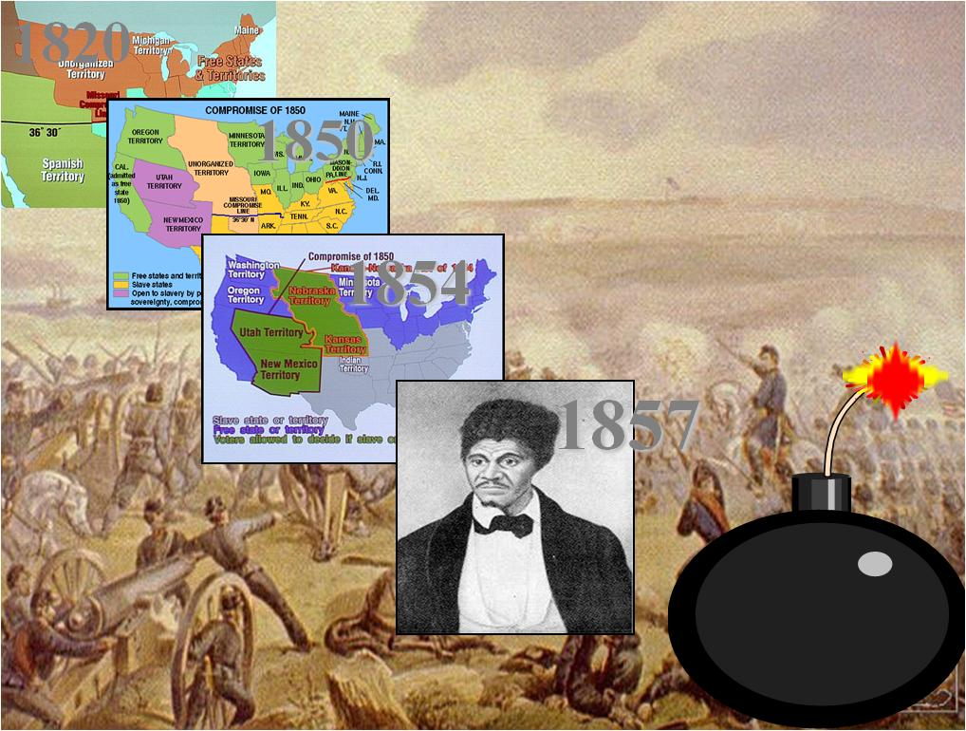

A slave, Dred Scott sued for his freedom on the ground that his master, an Army surgeon, had taken him into Illinois and then the Wisconsin Territory, where slavery had been barred by Congress in the Missouri Compromise. The Court, whose majority decision was read by Chief Justice Roger B. Taney, ruled that the Missouri Compromise was unconstitutional because it violated the property rights protected by the Fifth Amendment, since it denied slave owners the right to take their property wherever they wanted to. In effect, this decision opened all the West to slavery, infuriated the North, and pushed the nation more precipitously toward civil war.

Issue | Case | Decision
Monopolies | Northern Securities Co. v. United States (1903) | The Supreme Court upheld the government’s power under the Sherman Antitrust Act to stop monopolies from destroying free competition in the marketplace.
Freedom of Speech | Schenck v. United States (1919) | The Supreme Court said government could jail a socialist for encouraging soldiers not to fight during World War I. Individual freedom of speech could be suspended if there were a “clear and present danger” to society.
Racial Segregation | Brown v. Board of Education of Topeka  (1954) | The Supreme Court overturned Plessy decision. Segregation laws are Unfair and unequal because they treat one group racial as inferior.
Freedom of Religion | Engel v. Vitale  (1962) | The Supreme Court declared a state could not require school children to say a specific prayer.
Due Process Rights of Accused Persons | Gideon v. Wainwright (1963) | The Supreme Court said a state which refused to give legal counsel to a person accused of a crime violated the person’s 6th Amendment right.
Due Process Rights of Accused Persons | Miranda v. Arizona  (1966) | The Supreme Court said a person must be clearly informed of all Constitutional due process rights. Police must now read all suspects being placed under arrest the “four-fold warning” advising them of their 5th and 6th Amendment rights.
Presidential Power | United States v. Nixon (1972) | The Supreme Court said the President’s privilege to keep executive documents about his role in the Watergate scandal.
Press Censorship | New York Times v.  United States  (1972) | The Supreme Court said newspapers could publish secret Government documents they obtain under the 1st Amendment right of the people to be informed
Abortion | Roe v. Wade  (1973) | The Supreme Court said states cannot prevent women from having abortions during the first six months of pregnancy.

The Supreme Court
Key 20th Century Supreme Court Actions (by category)

The Executive Branch
The Role of the Presidency and the shaping of America

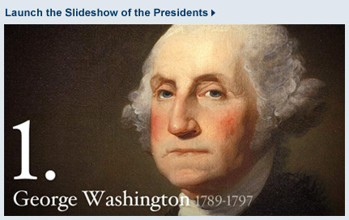  $AFE; Precedent President | 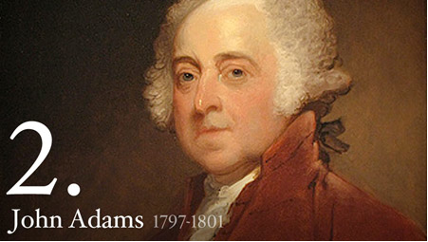  XYZ Affair; Alien and Sedition | 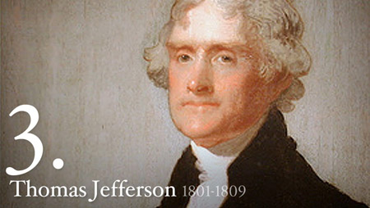  Louisiana Purchase, Embargo Act
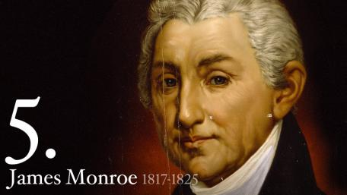  Era of Good Feelings? | 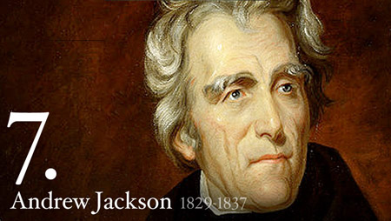  Jacksonian CUSP | 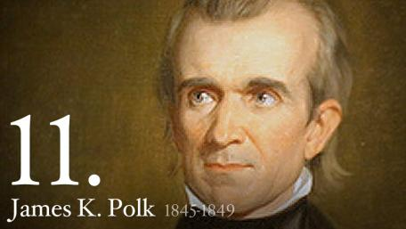  Manifest Destiny!!!
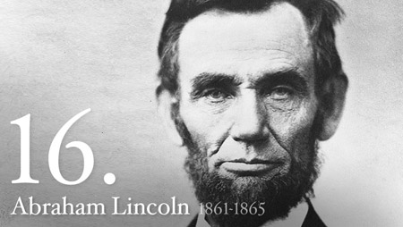  Civil War and Emancipation | 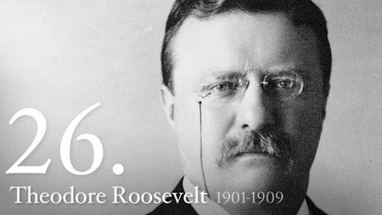  Big Stick and Bull Moose | 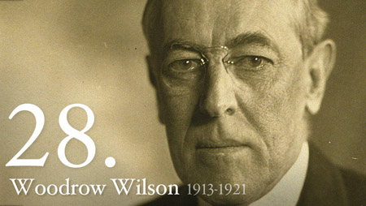  The Fed and WWI
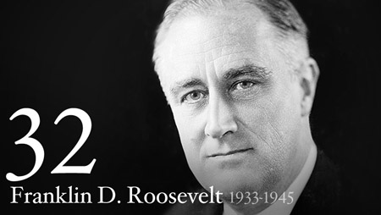Depression, New Deal, WWII | 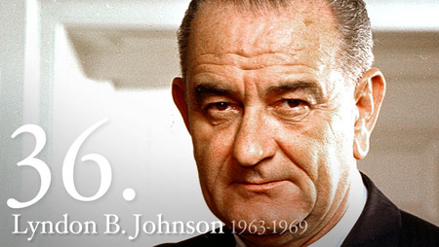The Great Society | 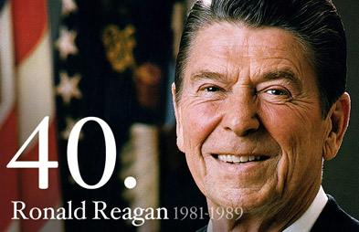  Reaganomics
The Executive Branch
Highlights of Presidential Administrations
President | Term | Party | Major Events/Developments
George Washington | 1789-1797 | Federalist | Establishes new government; Whiskey Rebellion; Jay Treaty; Farewell Address (SAFE)
John Adams | 1797-1801 | Federalist | Undeclared war with France; XYZ affair; Alien and Sedition Acts
Thomas Jefferson | 1801-1809 | (Democratic) Republican | First Republican president; Executed Louisiana Purchase; Embargo Act of 1807
James Madison | 1809-1817 | (Democratic) Republican | War of 1812
James Monroe | 1817-1825 | (Democratic) Republican | Florida purchase; Era of Good Feelings; Executed the Missouri Compromise and the Monroe Doctrine
John Q. Adams | 1825-1829 | (National) Republican | Corrupt bargain
Andrew Jackson | 1829-1837 | Democrat | Expands presidential power; Bank battle; Tariff/Nullification Crisis; Indian removal
Martin Van Buren | 1837-1841 | Democrat | Panic of 1837; Trail of Tears
William H. Harrison | 1841-1841 | Whig | First Whig president; Died in office
John Tyler | 1841-1845 | Whig | Annexation of Texas
James K. Polk | 1845-1849 | Democrat | Mexican-American War; Mexican Cession
Zachary Taylor | 1849-1850 | Whig | Last Whig president elected; Died in office
Millard Fillmore | 1850-1853 | Whig | Compromise of 1850
Franklin Pierce | 1853-1857 | Democrat | Kansas-Nebraska Act; Ostend Manifesto
James Buchanan | 1857-1861 | Democrat | Dred Scott decision; John Brown’s raid; Seven states leave Union
Abraham Lincoln | 1861-1865 | Republican | Civil War; Emancipation Proclamation; First president assassinated
Andrew Johnson | 1865-1869 | Republican | Reconstruction; First president impeached; Purchased Alaska
Ulysses Grant | 1869-1877 | Republican | Reconstruction continued; Many scandals
Rutherford B. Hayes | 1877-1881 | Republican | Compromise of 1877; Reconstruction ended
James Garfield | 1881-1881 | Republican | Second president assassinated
Chester Arthur | 1881-1885 | Republican | Pendleton Act

President | Term | Party | Major Events/Developments
Grover Cleveland | 1885-1889 | Democrat | First Democratic president since Civil War; Tariff battle with Congress
Benjamin Harrison | 1889-1893 | Republican | Built up navy; Grandson of William H. Harrison; McKinley Tariff
Grover Cleveland | 1893-1897 | Democrat | Only president to serve two nonconsecutive terms; Depression of 1893
William McKinley | 1897-1901 | Republican | Spanish-American War; Third president assassinated
Theodore Roosevelt | 1901-1909 | Republican | Trust buster; Square Deal reforms; “Big stick” in Caribbean
William Howard Taft | 1909-1913 | Republican | Dollar Diplomacy in Caribbean; Split with Theodore Roosevelt in 1912
Woodrow Wilson | 1913-1921 | Democrat | Progressive reforms; World War I; Fought for League of Nations
Warren Harding | 1921-1923 | Republican | Normalcy period; Political and personal scandals; Died in office
Calvin Coolidge | 1923-1929 | Republican | Pro-business, laissez-faire administration; Kellogg-Briand Pact
Herbert Hoover | 1929-1933 | Republican | Great Depression strikes; Promoted attitude of rugged individualism
Franklin D. Roosevelt | 1933-1945 | Democrat | New Deal reforms; World War II; Elected to four terms
Harry S Truman | 1945-1953 | Democrat | Fair Deal reforms; Cold War begins; Upset victory in 1948; Korean War
Dwight Eisenhower | 1953-1961 | Republican | Ended Korean War; Maintained peaceful coexistence with USSR; Established modern Republicanism
John F. Kennedy | 1961-1963 | Democrat | New Frontier reforms; Bay of Pigs; Cuban Missile Crisis; Assassinated 1963
Lyndon B. Johnson | 1963-1969 | Democrat | Great Society reforms; Civil rights acts; Escalated Vietnam War
Richard Nixon | 1969-1974 | Republican | Ended Vietnam War; Recognized China; Watergate scandal; First president to resign
Gerald Ford | 1974-1977 | Republican | Took over when Nixon resigned; Pardoned Nixon for his crimes
Jimmy Carter | 1977-1981 | Democrat | Camp David Accords; Iran Hostage Crisis
Ronald Reagan | 1981-1989 | Republican | Supply-side economics; Military buildup; Soviet Union’s Cold War decline began

The Executive Branch
Eight Elections that Shaped U.S. History

1800:  SUPRISING TIE | Four men competed for the offices of President and Vice President. U.S. President John Adams and Thomas Pinckney were both Federalists. Aaron Burr and U.S. Vice President Thomas Jefferson were Democratic-Republicans. The candidate who won the most electoral votes would become President; the runner-up would become Vice President. It was a bitter campaign—the first to involve political party machinery and organized campaigning. But it made the record books for another reason. Jefferson and Burr tied for first place, with 73 electoral votes each. The House of Representatives took over, as the Constitution required. Its members chose Jefferson as President and Burr as Vice President. In office, Jefferson worked to change the method of electing Vice Presidents. The Constitution’s 12 th Amendment, ratified in 1804, instructs electors to cast separate votes for President and Vice President.
1824:  UNPOPULAR VICTORY | In a four-way race, Andrew Jackson of Tennessee got the most popular votes (153,544) and electoral votes (99). Yet John Quincy Adams, with 108,740 popular votes and 84 electoral votes, became President. To win outright, a candidate has to win a majority. Then 131 votes—in the Electoral College. Since two other candidates won a total of 78 votes, no candidate had a majority in 1824. So, the U.S. House of Representatives took over, and its members chose John Quincy Adams. Throughout the U.S., there was a feeling that the House had gone against the will of the people. In the next election (1828), Jackson trounced Adams.
1860:  A NATION DIVIDED | Of the four Presidential candidates, Abraham Lincoln was the least known. His chief rival, U.S. Senator Stephen A. Douglas, was a leading spokesman for the Democratic Party. However, that party, like the nations, was split on the slavery issue.  When Southerners bolted from the 1860 Democratic convention, the Northern Democrats, who stayed, nominated Douglas for President. The Southern Democrats chose John Breckinridge, and the Constitutional Union movement chose John Bell, another breakaway Democrat. To oppose these Democrats, the young, anti-slavery Republican party nominated Abraham Lincoln. Though Lincoln was not in favor of abolishing slavery, Southerners believed he was, and abolitionists supported him. Lincoln won. On hearing the news, South Carolina’s legislature called a state convention, which on December 20 voted to sever the state’s ties to the federal union. Over the next six weeks, 10 other Southern states seceded from the Union.
1876:  A LOSER WINS | The Democrats nominated Samuel J. Tilden, a popular governor of New York. Tilden got 4,284,020 popular votes; Rutherford B. Hayes, the Republican governor of Ohio, got 4,036,072. Tilden won 184 electoral votes and Hayes won 166. But Tilden did not win the election. To do that, he needed 185 electoral votes-then a majority of the Electoral College. Neither candidate won a majority because of irregularities in three Southern states, which left 19 electoral votes in dispute and, therefore, uncounted. To settle the dispute, President Grant appointed an Electoral Commission. Seven of its members were Republicans; six were Democrats. Commission members negotiated with Southern governors, legislators, and electors. Deals were made. Finally, all 19 electoral votes went to Hayes, who ended up with 185 electoral votes to Tilden’s 184
1912:  THIRD-PARTY WEDGE | In a Presidential election, the incumbent usually has a advantage. But that was definitely not the case in 1912. Incumbent President William Howard Taft won only eight electoral votes! His Democratic opponent, Woodrow Wilson, won 435.Taft’s problems resulted mostly from the candidacy of a former Republican President, Theodore Roosevelt. In 1908, Roosevelt had supported Taft. However, by 1912, a split had developed between the Republicans’ conservative wing, led by Taft, and its progressive wing, led by Roosevelt. When Taft was nominated at the Republican Convention, Roosevelt organized the Progressive “Bull Moose” Party. As the Progressive candidate, Roosevelt won 88 electoral votes.
1948:  THE POLLSTERS’ DEFEAT | Democratic prospects seemed hopeless in 1948. Harry Truman, who had become President on Franklin D. Roosevelt’s death in 1945, had little popular appeal. He faced a strong Republican contender, Thomas E. Dewey, and third-party pressures from Progressives and “Dixiecrats.” (Southern Democrats in the States’ Rights Party)  Political experts-and nearly every public opinion poll-predicted a Dewey victory. Chicago’s Tribune (see photo) felt safe in printing a “Dewey Defeats Truman” headline before all the votes were counted. Actually, Truman defeated Dewey-with 24,105,812 popular votes and 303 electoral votes. Dewey won 21,970,065 popular votes and 189 electoral votes.
1960:  THE FIRST TV DEBATES | John Kennedy had two strikes against him, many thought. First, he was a Catholic, and many remembered how Herbert Hoover had beaten another Catholic, Alfred E. Smith, in 1928. Second, Kennedy faced a tough Republican opponent-Richard M. Nixon, who had been Vice President during the two Eisenhower Administrations.  But four TV debates-the firs ever for Presidential candidates-helped Kennedy defuse the religion issue and take some of the luster off Nixon’s image. On TV, Nixon appeared nervous, sweaty, tired, defensive, and in need of a shave.  Kennedy seemed calm, collected, sophisticated, and mature. Political analysts feel that the debates gave Kennedy the edge he needed to squeak through to victory.
1964:  HARD-HITTING ADS | In 1964, hard-hitting TV ads became a major weapon in a Presidential candidate’s arsenal. The TV commercials used in the 1952, ’56, and ’60 campaigns were simple presentations of the candidates’ abilities and stands on issues. What made the TV ads in the ’64 campaign different were the “hidden messages” that put the opposition in a bad light. For instance, an ad for the Democratic candidate, Lyndon Johnson, showed a little girl counting backwards as she pulled petals from a daisy. The countdown ended with an atomic explosion. The not-so-hidden message: a vote for Barry Goldwater, the Republican candidate, could mean nuclear war.  The Goldwater camp used TV ads of this type, too. But the Johnson forces created the most. The TV ads were so hard-hitting-one media expert called them “bitter and vicious” – that some people wanted political ads outlawed. But, 20 years later, political ads on TV are still with us, along with the issue of their

GEORGE WASHINGTON’S FAREWELL ADDRESS (1796) | in which he stressed the importance of national unity as the “main pillar” of the nation’s independence, peace, and prosperity.
ABRAHAM LINCOLN’S “HOUSE DIVIDED” SPEECH (1858) | delivered on the occasion of his nomination as the Republican candidate for senator from Illinois. This was probably Lincoln’s most radical statement about the implications of the slavery issue, the one in which he predicted that “this government cannot endure permanently half slave and half free.” It got him in some trouble with Northern conservatives, especially when opponents quoted the remark out of context in order to suggest that Lincoln was an abolitionist. Lincoln did not, in this speech or on any other occasion before the war, call for the abolition of slavery.
WILLIAM JENMNGS BRYAN’S “CROSS OF GOLD” SPEECH (1896)  NOTE: Bryan lost his bid for the White in 1896. He was never President | at the 1896 Democratic National Convention. Bryan, arguing for a plank in the party platform calling for the free coinage of silver, ended with the sentence “You shall not press down upon the brow of labor this crown of thorns, you shall not crucify mankind upon a cross of gold.” “You” were the Gold Democrats, the supporters of the incumbent President, Grover Cleveland, who opposed the unlimited coinage of silver. The speech made a national figure of the thirty-six-year-old Bryan and led to his nomination for the Presidency by the convention.
WOODROW WILSON’S CALL FOR DECLARATION OF WAR AGAINST GERMANY (1917) | which contains the famous line “The world must be made safe for democracy.” The speech is remarkable for Wilson’s insistence that “we have no quarrel with the German people. … We fight without rancor and without selfish object.” Such forbearance and Wilson’s promise that victory would result in a “universal dominion of right” helped win liberal support for the war effort, but it contributed to postwar disillusionment when his idealistic hopes were not realized.
FRANKLIN D. ROOSEVELT’S FIRST INAUGURAL ADDRESS. (1933) | remembered for the line “the only thing we have to fear is fear itself,” for Roosevelt’s promise “to put people to work,” and perhaps for use of the phrase “good neighbor” when referring to foreign policy. It was an extraordinarily effective speech, but it also contained a good deal of windy political foolishness, and a considerable amount of bad advice. For example, the President felt it necessary to point out that “happiness lies not in the mere possession of money”; he promised to balance the federal budget and urged state and local governments to reduce their expenditures “drastically
The Executive Branch
Five Speeches to Remember 1796 to 1933

Economic and Labor History
Hamilton’s Financial Plan to Taft Hartley

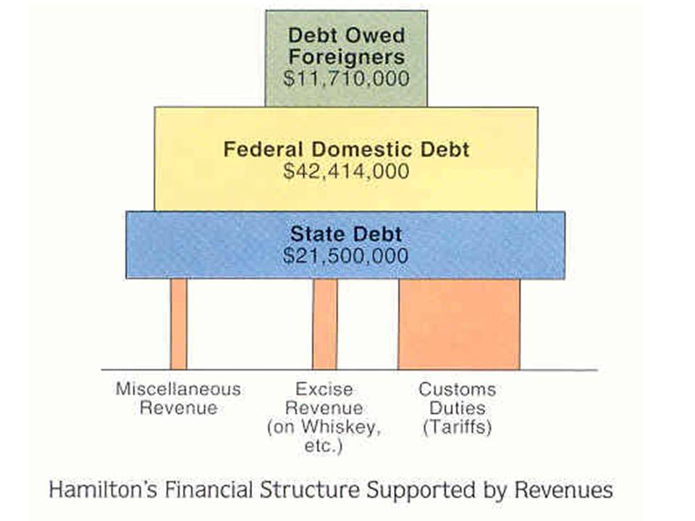  Hamilton’s Financial Plan (1791) | 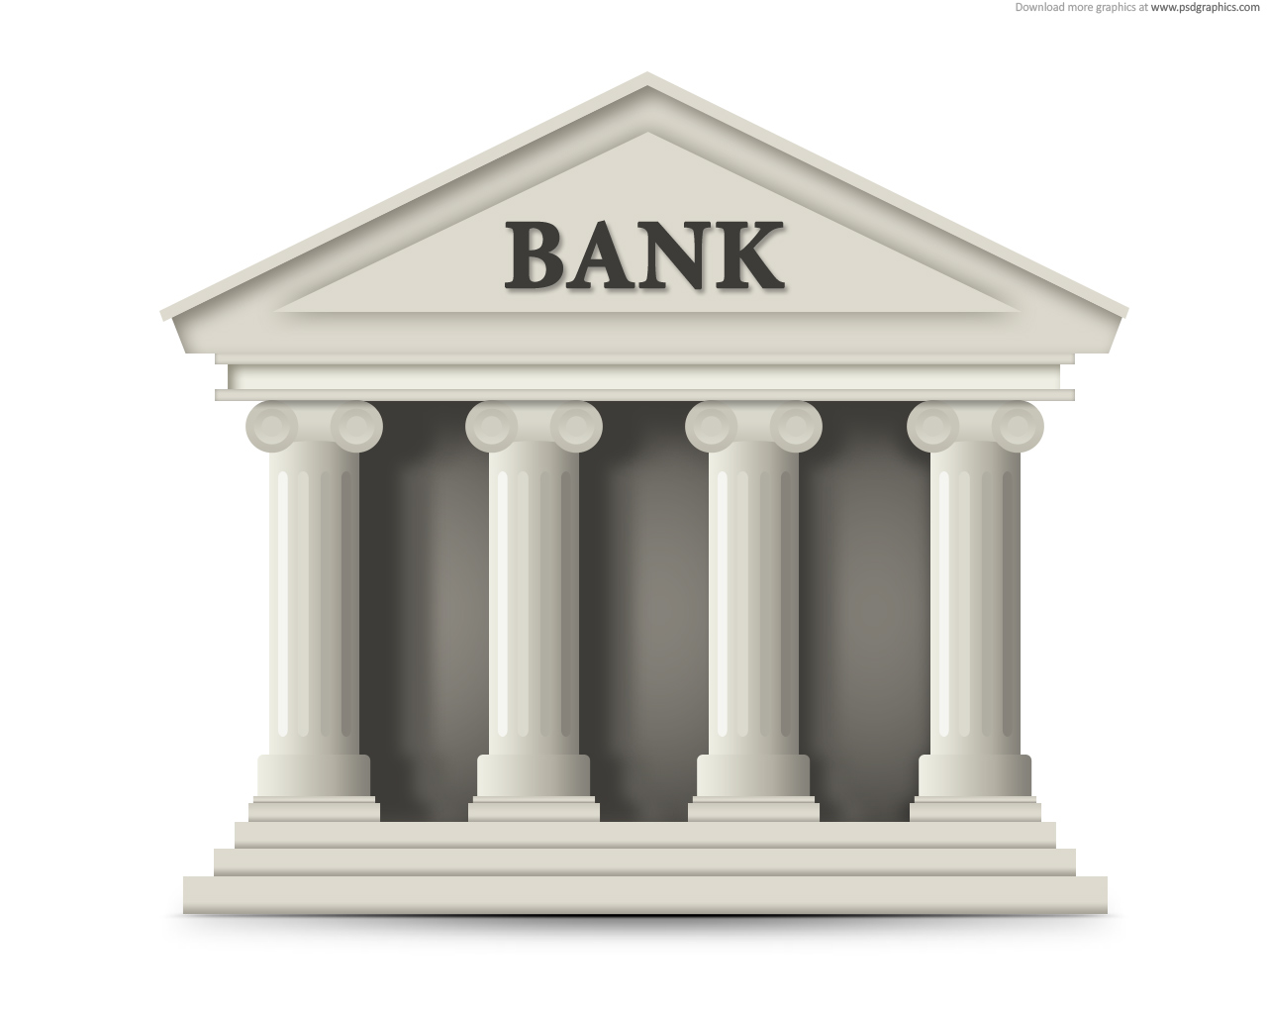  The National Bank | 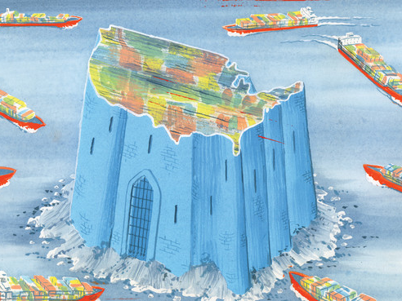  Tariff History
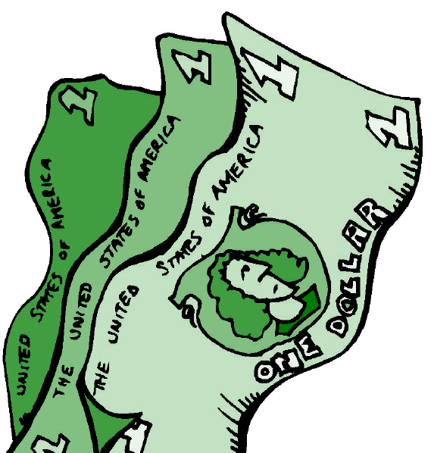  The U.S. Economy | 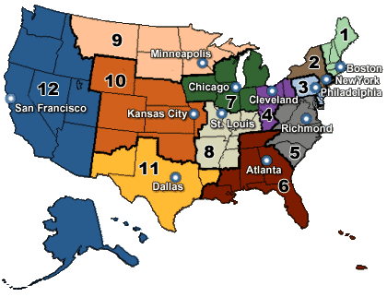  The Federal Reserve | 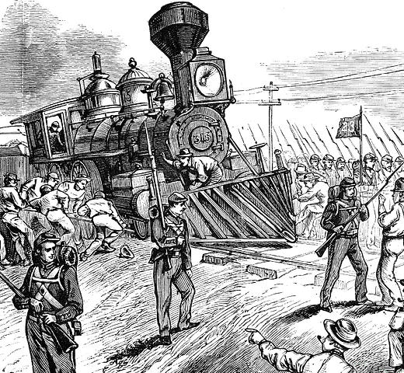  Labor Disruptions and Strikes
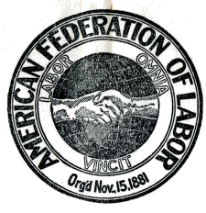  Labor Union and Organizations | 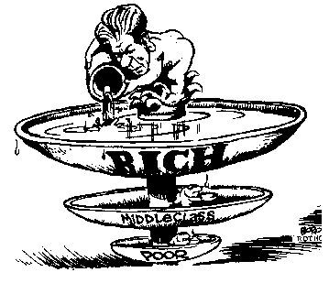  Supply side Economics | 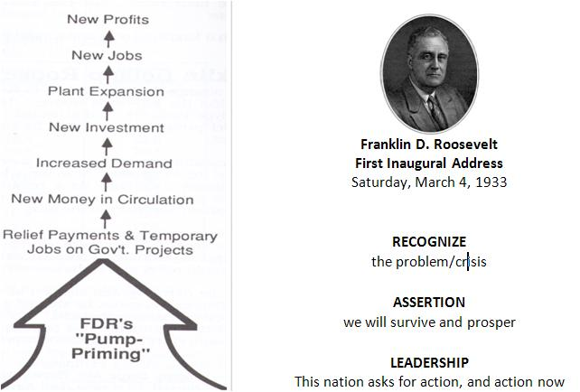  Keynesian Economics
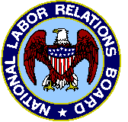  The Wagner Act 1932 |  | 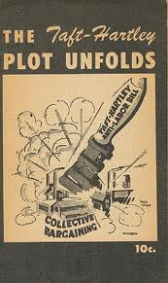  Taft Hartley Act (1947)

United States Economic History
A Quick Overview

Discovery of America
Scarcity of Goods in Western Europe

Colonial Times
Scarcity of Land in Western Europe
Scarcity of Labor in the Colonies
Joint-Stock Company

Eighteenth Century
Mercantilism vs. Salutary Neglect
Hamilton vs. Jefferson: National Bank, Tariff, National Debt

Nineteenth Century
Transportation
Sectionalism / Nationalism
Scarcity of Land for Cotton Cultivation
Industrialization / Gilded Age
Scarcity of Resources: Closing of the Frontier

Twentieth Century
Progressive Era
Financial Capitalism
Scarcity of Labor in Wartime
Scarcity of Energy
Regulated Capitalism
Deregulated / Laissez-faire Capitalism

Essay Questions:
Analyze the evolution of American capitalism during [insert time period here].

United States Economic History
Hamilton’s Financial Plan

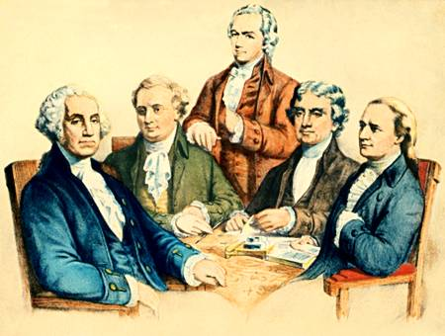
Alexander Hamilton believed the economic stability of the nation was determined by its industrial might. He created a plan to provide a strong monetary system for merchants, creditors, and manufacturers.

Bank of the U.S.; Excise Taxes;
Funding at Par; Assumption of State Debts; Tariffs

United States Economic History
Tariffs (Custom Duties)

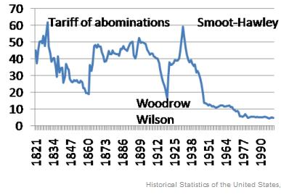
Tariff of 1789 | the first tariff law; called for about 5-15% of the value of dutiable imports. The main goal was to raise revenue, but also designed to raise erect a low protective wall around the infant industries
Tariff of 1816 | the tariff in American history with aims that were primarily protective; begins a strong protective trend; levied heavy duties on imported manufactured goods; helped northern industry from the onslaught of British goods
Sectional Tariff of 1824: | the former level of 20-25% (Tariff of 1816) was raised to 37% under President Monroe
“Tariff of Abomination”/The Tariff of 1828 | Jacksonites pushed duties up to 45% on certain manufactured goods and raw materials, which northern manufacturers so urgently needed, notably wool. They hoped that even industrial sections would vote against it rather than support it. Hoped to hurt John Quincy Adams; backfired; upset the South; raised rates
Tariff of 1832 | lowered the imposts to about the level of Tariff of 1824 (35%); frankly protective; seemed permanent to the South; led to nullification crisis
Compromise Tariff of 1833 | Tariff of 1832 would be gradually reduced by 10% over 8 years and by 1842 it would be about 20-25%; lowered rates
Walker Tariff  1846 | reduced the average rates of the Tariff of 1842 from 32% to 25%; unites rural and agricultural factions; excellent as a revenue producer; lowered rates

Tariff of 1857 | reduced duties to about 20% on dutiable goods – the lowest since the War of 1812; the surplus in the treasury melted away; lowered rates
Morill Tariff 1861 | North needed revenue with war coming; raised rates to protect industry; raised rates twice between 1861 & 1862
McKinley Tariff 1888 | rates were raised to the highest peacetime level yet; an average of 49%; brought new woes to the farmer; kept protection high and surplus low; raised rates
Payne-Aldrich Tariff 1909 | Taft campaigned for tariff “reform” which many thought meant lower tariffs; lowered the protection on Midwestern farm products, while raising rates favorable to his Northeast.
Underwood Tariff 1913 | cut rates, but the coming of world war in 1914 radically revised trade patterns. Reduced trade and, especially, the new revenues generated by the federal income tax made tariffs much less important.
Smoot-Hawley Tariff 1930 | highest protective tariff in peacetime history; duties raised from 32% to nearly 60%; Canada, Britain, Germany, France and other industrial countries retaliated with their own tariffs and special, bilateral trade deals. American imports and exports both went into a tailspin.
General Agreement on Tariffs and Trade (GATT) 1947: | minimize tariffs and other restrictions, and to liberalize trade among all capitalist countries. In 1995 GATT became the World Trade Organization (WTO); with the collapse of Communism its open markets/low tariff ideology became dominant worldwide in the 1990s.
North American Trade Agreement (NAFTA) 1994: | It was based on George H. W. Bush's plan to enlarge the scope of the market for American firms to include Canada and Mexico. US President Bill Clinton, with strong Republican support, pushed NAFTA through Congress over the vehement objection of labor unions; in 2000 he worked with Republicans to give China entry into WTO and "most favored nation" trading status (i.e., low tariffs).

United States Economic History
The Federal Reserve Act 1913

In 1913 he signed the epochal Federal Reserve Act , the most important piece of economic legislation between the Civil War and the New Deal.

The country’s financial structure, still creaking along under the Civil War National Banking Act, revealed glaring defects. Its most serious shortcoming, as exposed by the panic of 1907, was the inelasticity of the currency.

Banking reserves were heavily concentrated in New York and a handful of other large cities and could not be mobilized in times of financial stress into areas that were badly pinched.

The "Fed" had the power to raise and lower interest rates and issue paper money. These tools enabled the Federal Reserve Board to control credit and the supply of money

United States Economic History
The role of the National Government in the Economy

The U.S. has a capitalistic economic system. This means buyers and sellers interact to set prices and wages with some regulation by the government. The U.S. government’s role in the economy has changed drastically from their laissez-faire policy of the late 1800’s. Starting with Franklin Roosevelt’s New Deal, which was enacted to rid the U.S. of the Great Depression, the government has assumed a much larger regulatory role in the economy. Today, the political debate has centered around the extent to which the government should regulate the economy. In general, the Democrats favor government’s continued regulation of the economy while the Republicans seek to limit government’s regulatory role.

U. S. ECONOMIC POLICIES

LAISSEZ-FAIRE ECONOMICS: Until the New Deal, the U.S. employed a system of laissez-faire capitalism. The government felt that the free market economic system would operate best with little or no interference by government.

KEYNESIAN ECONOMICS: Franklin Roosevelt’s New Deal used the economic policies of John Maynard Keynes in an effort to rid the country of the Great Depression. Keynes felt the government could help correct the economic problems of a nation by altering its spending, taxes, and borrowing policies. Keynes felt the government should spend more money than it receives in taxes during a recession or a depression. This extra influx of money would create jobs and stimulate demand causing the economy to strengthen. When there is a high rate of inflation, Keynes recommended the government should spend less money then it receives in taxes. This would reduce money in circulation. Lowering demand, which should reduce inflation. Keynesian economics relies on the government to take an active role in the economy.

SUPPLY SIDE ECONOMICS: During the late 1970’s and early 1980’s, the U.S. economy was faced with stagflation (high unemployment and high inflation). President Reagan used supply-side economics to stimulate the economy. Under this plan, production of goods and services was seen as the key to lowering inflation and creating employment. Reagan, under this plan: 1) reduced income tax percentages; 2) reduced government spending for social programs; and 3) reduced government regulation of business. By 1988, employment increased and inflation was in check. But, the national debt and yearly government deficit has increased sharply.

United States Labor History
A Quick Overview

Unions
National Labor Union (1866-1869) William H. Sylvis
Knights of Labor (1879) Uriah S. Stephens / Terence Powderly (1879-1990s)
American Federation of Labor (1881) Samuel Gompers
International Workers of the World / Wobblies (1905) – Socialist dominated, radical, violent
Committee for Industrial Organization (1938) – John Lewis; Semi-skilled & unskilled
AFL & CIO merge to AFL-CIO (1955)

Strikes
Haymarket Square (1886) Chicago, IL – Knights of Labor
Homestead Steel Strike (1892) Carnegie Steel, Penn. – Amalgamated Iron & Steel Workers; AFL
Pullman Strike (1894) Chicago, IL – American Railway Union
Anthracite Coal Strike (1814 & 1902) – Midwest and Pennsylvania – United Mine Workers

Court Cases
Commonwealth vs. Hunt (1842) in a Massachusetts State Supreme Court
In re Debs (1895)
Danbury Hatters Strike (1902 strike brought to the U.S. Supreme Court – definitively upholds a practice that had been performed throughout the end of the 19th century: ruled in 1908 that the Sherman Anti-Trust Law of 1890 could be used against unions when they strike because the act of a strike is “in restraint of trade”)

Federal Legislation
Sherman Anti Trust Act 1890
Department of Labor created in 1913
Clayton Anti-Trust Act (1914)
Labor was not a “commodity” and could not be prosecuted as in “restraint of trade,”; limited the use of injunctions and prohibited injunctions against peaceful picketing
Adamson Act (1916)
Norris-LaGuardia Act (1932)
Outlawed yellow dog contracts.Forbade federal courts to issue injunctions to restrain strikes, boycott, and peaceful picketing.
Wagner (National Labor Relations) Act (1935) Forbid company unions; Management must bargain collectively with labor when labor chooses to form a union; National Labor Relations Board is set up to settle disputes/complaints between management and labor
Fair Labor Standards (Wage and Hours) Act (1938)
Taft-Hartley Act (1947)
Section 14b added – “right to work” measure: 20 states mostly southern, prohibit compulsory union membership stating that no worker can be compelled to join a union in order to hold a job.

United States Economic History
The Labor Movement in American History 1842 to 1947
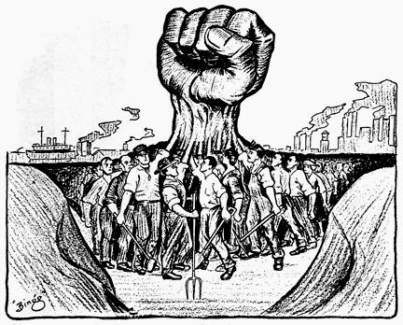
"Sweat of the laborer lubricated the vast new industrial machine. Yet the wage workers did not share proportionately with their employers in the benefits of the age of big business."
Factories first appeared in the United States during the late 1700’s and early 1800’s. The owners of the factories required people to work long hours at low pay. Buildings were poorly lighted and heated. Many jobs were dirty, monotonous and dangerous. But is a worker complained, he was quickly replaced by one of the many persons looking for a job.
As time went on, some workers decided to join together and make demands as a group. It would be harder for the factory owner to replace a group of experienced workers than a single worker. Such an organization was called a “labor union”. The union wanted higher wages, fewer hours of work, and better working conditions.
A number of weak local unions appeared during the late 1700’s and early 1800’s. But it was not until after the Civil War that stronger national unions were organized. These included the Knights of Labor, American Federation of Labor, and Congress of Industrial Organizations. The letter two unions eventually merged in 1955 to form the powerful AFL-CIO.

United States Economic History
Management vs. Labor
“The average worker can never obtain more than a minimum level of living. The worker is deprived of the wealth he himself created. The state is a committee of bourgeoisie for the exploitation of the people.”
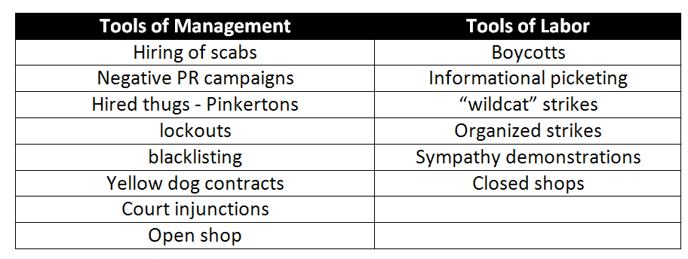
Union/Founder/Year | Membership | Comments
Knights of Labor  Uriah S. Stephens  1869 | Open to all workers, both skilled and unskilled. Reached a peak membership of 700,000 in 1885 | Took part in a number of railroad strikes, winning only one of them. Declined in importance after failing to win 8-hour day, better pay, improved working conditions, and a limit on child labor.
American Federation of Labor  (AF of L) Samuel Gompers 1886 | Included only skilled workers belonging to particular crafts, such as machinists, carpenters, and plumbers. Thus, the skilled workers in a factory belonged to different national unions. Reached 8 million members by 1955. | Favored settling disputes peacefully in order to avoid long, costly strikes. Objectives: Higher pay, shorter hours, better working conditions, end of child labor, limits on immigration
Congress of Industrial Organizations (CIO) Led by John L. Lewis 1938 | Included all skilled and unskilled workers in a single industry, such as all automobile workers in the United States. Membership of 6 million in 1955. | Consisted of more than 30 industrial unions, including the automobile, steel, oil-refining, textile, and shipbuilding industries. Wanted higher pay and more fringe benefits for workers.

United States Economic History
The Labor Movement in American History 1842 to 1947
1842 | Commonwealth v. Hunt | Legalized by in 1842, labor unions tended to be small and limited to skilled trades
1877 | Munn v. Illionis | RRDs discriminated against farmers, so IL passed pro-farming legislation in the Grange Laws. This was challenged by the corporations, but the SC ruled in favor of state regulation b/c it had a direct effect on the general public.
1877 | Great Railroad Strike | July, 1877 - A large number of railroad workers went on strike because of wage cuts. After a month of strikes, President Hayes sent troops to stop the rioting. The worst railroad violence was in Pittsburgh, with over 40 people killed by militia men.
1886 | Haymarket Square Riot | 100,000 workers rioted in Chicago. After the police fired into the crowd, the workers met and rallied in Haymarket Square to protest police brutality. A bomb exploded, killing or injuring many of the police. The Chicago workers and the man who set the bomb were immigrants, so the incident promoted anti-immigrant feelings.
1886 | Wabash, St. Louis and Pacific RR Co. v. IL | Reversal of 1877 decision, only the federal gov’t was declared able to regulate interstate commerce.
1892 | Homestead Strike | The workers at a steel plant in Pennsylvania went on strike, forcing the owner to close down. Armed guards were hired to protect the building. The strikers attacked for five months, then gave in to peace demands.
1894 | Pullman Strike | Chicago temporarily stopped railroad traffic and required federal intervention. American Railway Union led by Eugene Debs, they started the Pullman strike, composed mostly of railroad workers.
1869 | Knights of Labor | Sought to create one big union of all workers, skilled and unskilled. Opposed to strikes
1886 | American Federation of Labor (AFL) | (1886). Organized by Samuel Gompers. Focused on higher wages, shorter hours, and safer working conditions
1887 | Interstate Commerce Act | it forbid Railroads to form pooling agreements to charge more for a short haul than for a long haul under the same conditions and same traffic to grant rebates - initially ineffective
1890 | Sherman Anti-Trust Act | it made illegal “every contract, combination in the form of a trust or otherwise or conspiracy in restraint of trade or commerce among several states or with a foreign nation” it authorized prosecutions by the federal district attorneys and suits for damages by any individual or firm injured by a company in violation of the Act’s provisions
1892 | American Railway Union and Eugene Debs | Socialist approach that viewed government and owners as enemies of workers
1895 | US v. EC Knight Co. | Sugar company had monopolized industry, so Cleveland ordered a case against the trust, but the SC ruled that the sugar people were in manufacturing, not commerce, so it was okay.
1902 | Anthracite Coal Strike | Strike by the United Mine workers in the anthracite coal fields of Pennsylvania. President Roosevelt intervened on the labor dispute as an neutral arbitrator
1935 | The Wagner Act  (National Labor Relations Act) | The Magna Carta of Labor because it ensured workers’ rights to organize and bargain collectively
1935 | Congress of Industrial Workers (CIO) | Led by John L. Lewis the CIO organized unskilled and semiskilled workers in basic manufacturing industries such as steel and automobiles.  AFL favored the organization of workers according to their skills and trades. The CIO favored the organization of all workers in a particular industry.
1947 | The Taft-Hartley  (Management Relations Act of 1947) | Whereas the Wagner Act had spoken only of the right to participate in union activities, The new act included the right to refrain from union activities.

United States Labor History
Labor Management Relations 1935 to 1947

Early labor unions had a difficult time achieving their goals of higher pay, shorter hours, and improved working conditions. Factory owners were strongly against the formation of unions. They pressured the government to pass laws which restricted union activities. Federal troops were sometimes used to forcefully end strikes. The courts usually sided with the factory owners and ordered striking employees back to work. Workers at a factory who tried to start a union were regarded as troublemakers and were often dismissed from their jobs. Most early unions, including the Knights of Labor, failed to make significant gains and eventually disappeared. But the American Federation of Labor attracted large numbers of workers and made important progress toward its goals.
As unions grew in strength, labor (the worker) and management (the factory owners) used different tactics against each other. Some of the terms in the following list refer to measures taken by labor to put pressure on management. Others represent tactics used by management to limit the power and success of the unions. Two terms in the list refer to methods used to settle differences between the two sides. Fill in the spaces below with the appropriate answers.

The Wagner Act 1935  (National Labor Relations Act ) | The Taft-Hartley Act  (Management Relations Act of 1947)
The Wagner Act 1935  The act provided for collective bargaining, handling labor disputes and recognized the right of workers to choose representatives to represent themselves in a bargaining unit. The act included the right for employees to unionize and also established the National Labor Board (NLB)  National Labor Relations Act 1935  This law set limits on how employers may react to employees that organize or try to organize labor unions, engage in collective bargaining, and take part in strikes and other forms of mutual activity to support their causes | The Taft-Hartley Act  (also known as the Labor Management Relations Act of 1947), was created after a great number of large-scale strikes had nearly disabled the automobile, steel, and packing industries, among others.  These work stoppages had caused a ripple effect through the economy, leading to public panic.  The Taft-Hartley Act, an amendment to the Wagner Act of 1935, was designed to benefit all parties to a labor agreement the employer, employees, and the labor union.  Whereas the Wagner Act had spoken only of the right to participate in union activities, the new act included the right to refrain from union activities.  It was clear that this new act was designed to level the unfair playing field formerly tipped in favor of labor unions.

